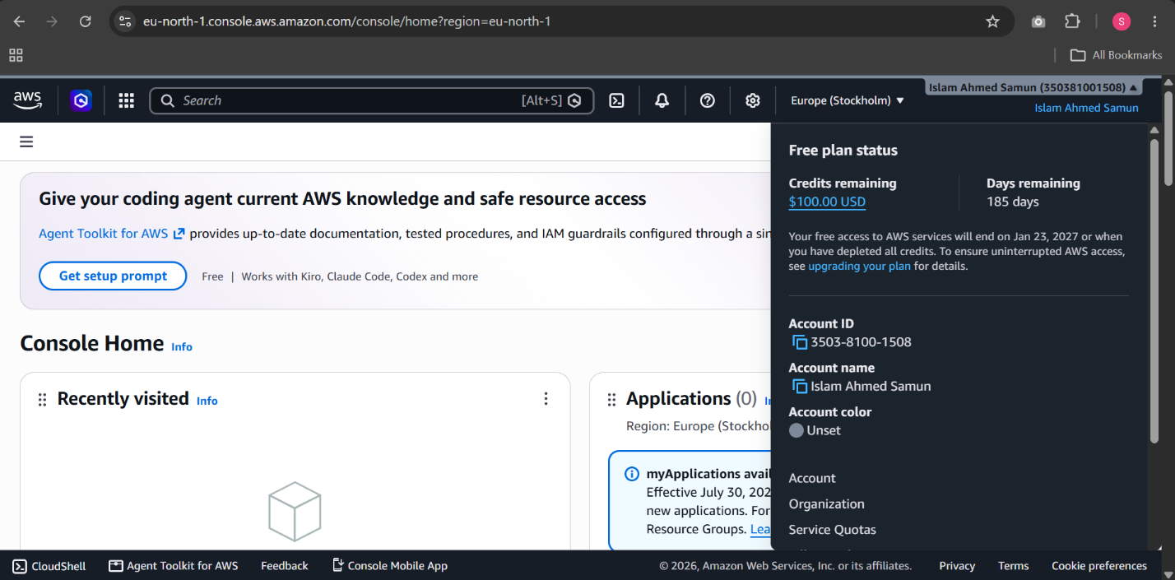
Phase 1

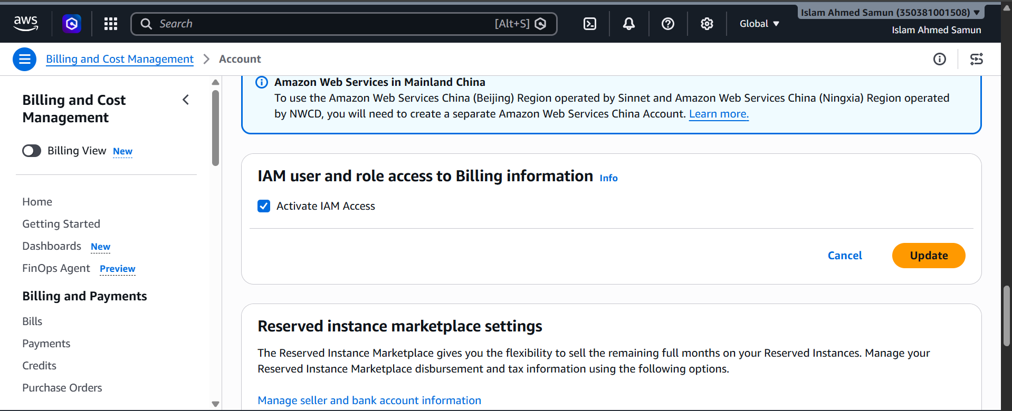

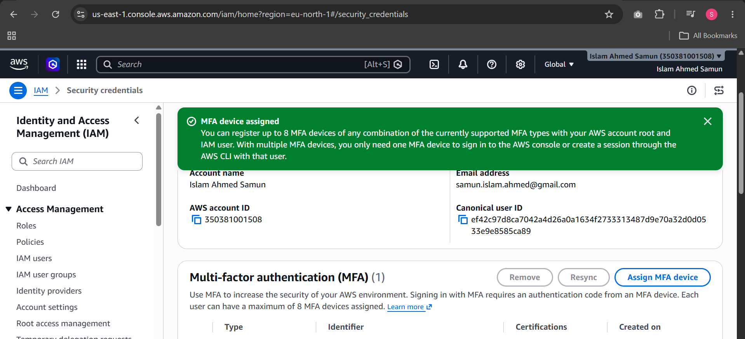

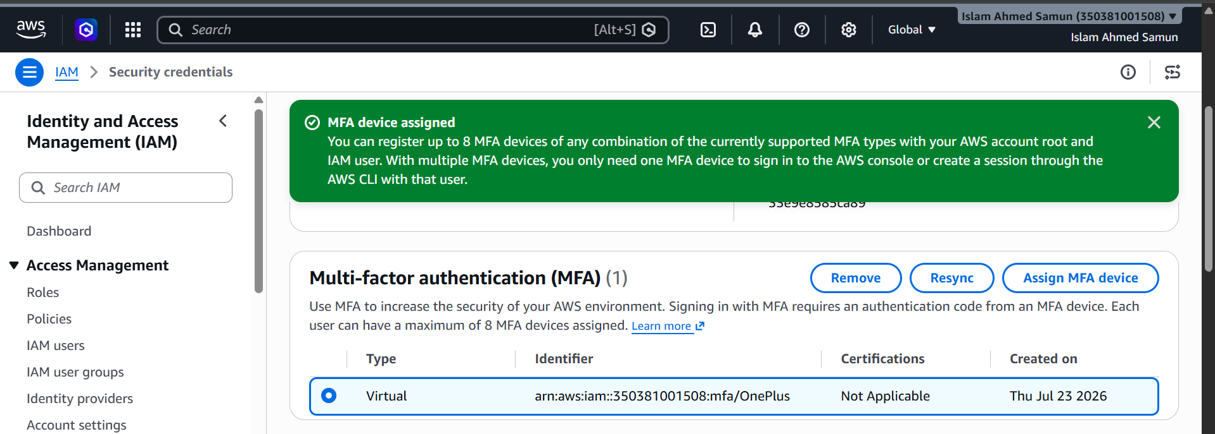

Phase 2:

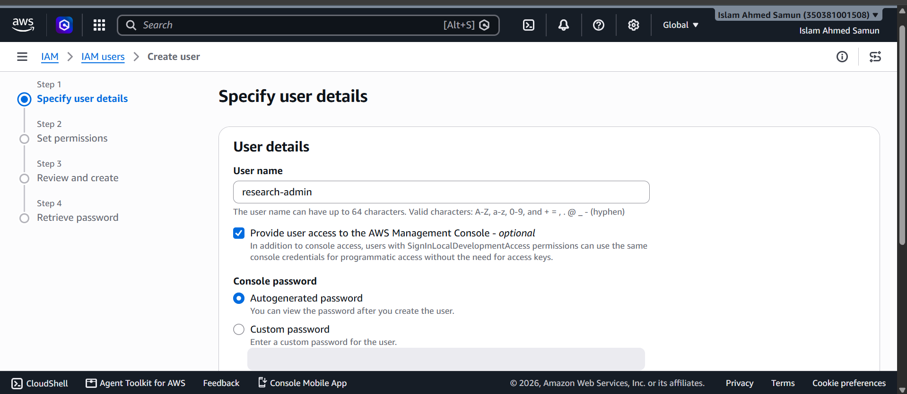

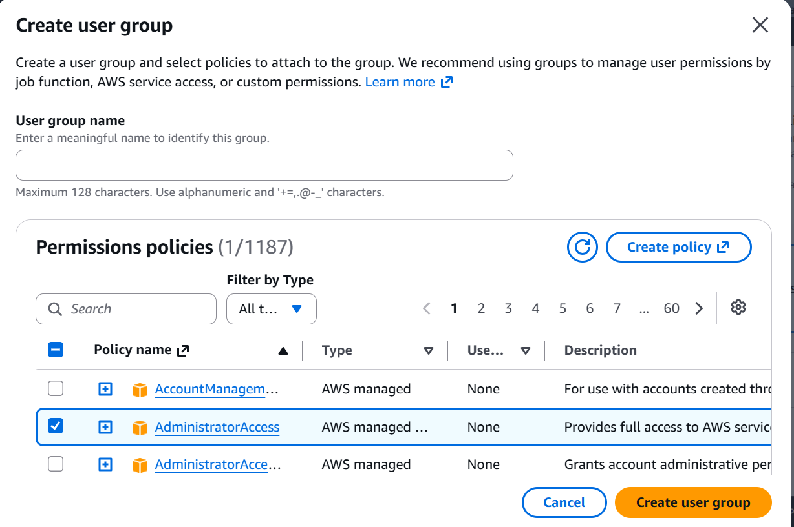

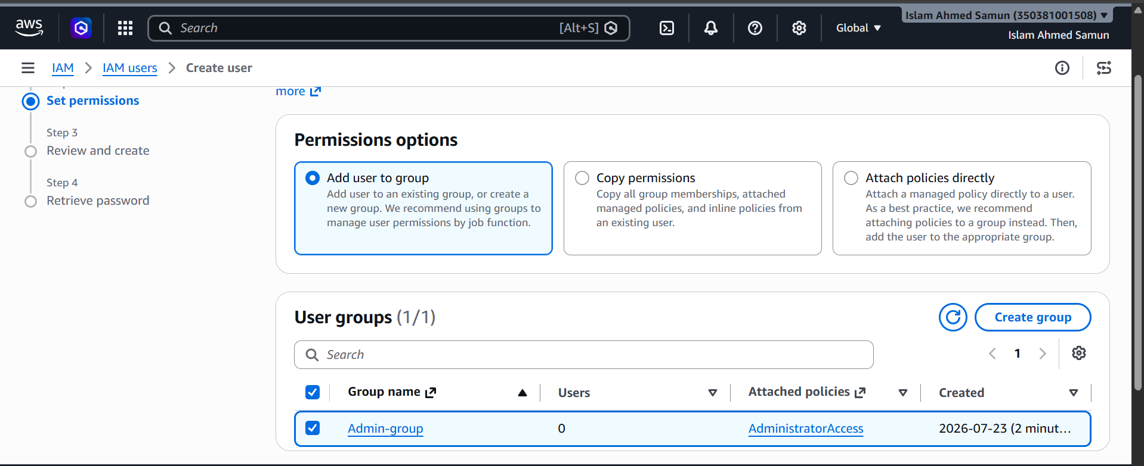

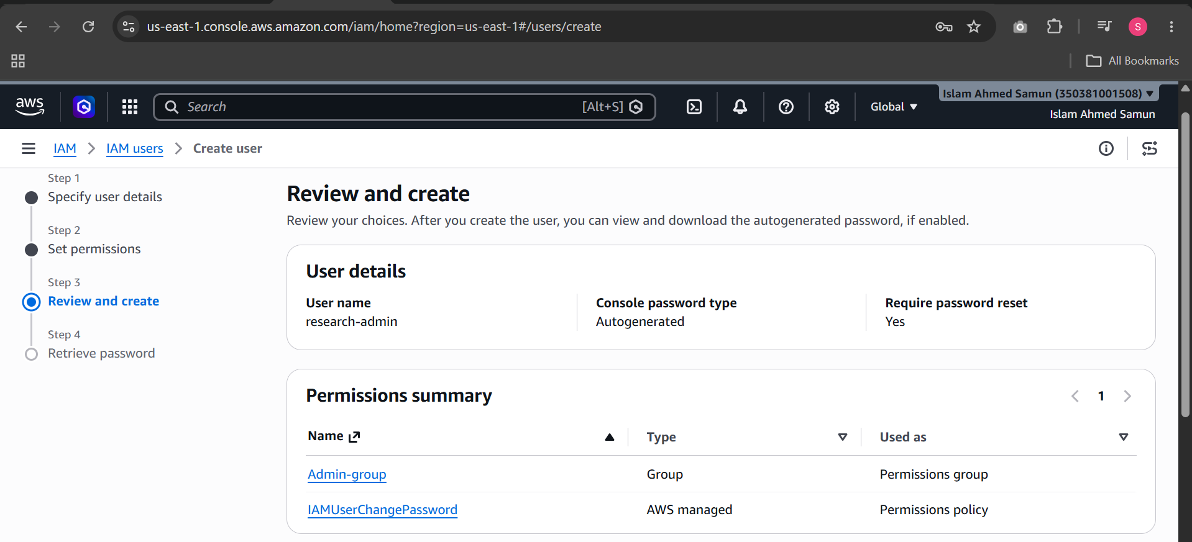

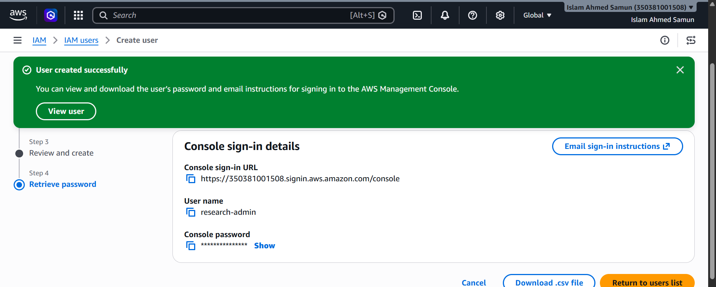

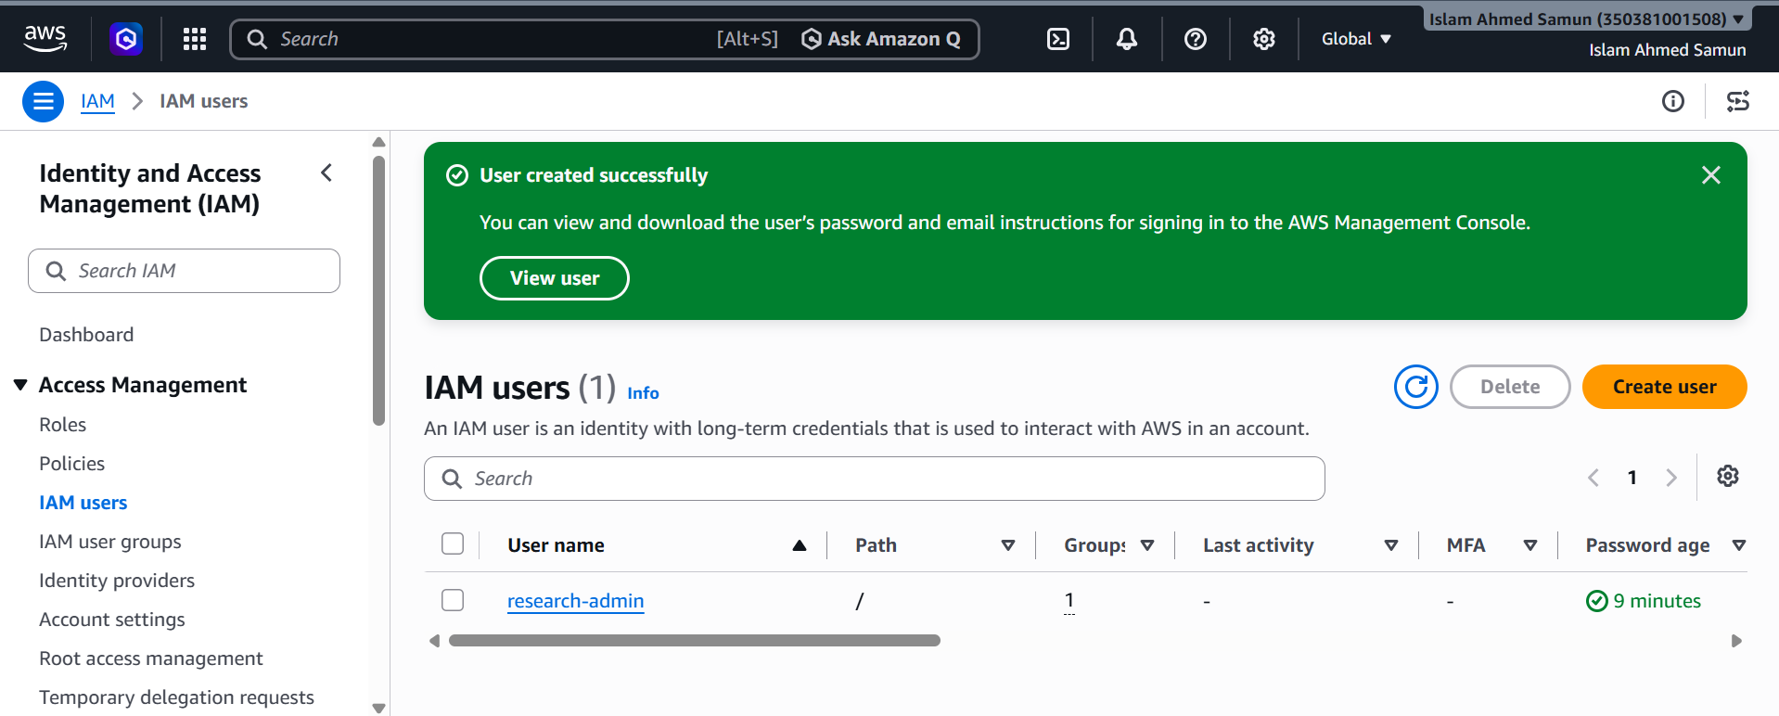

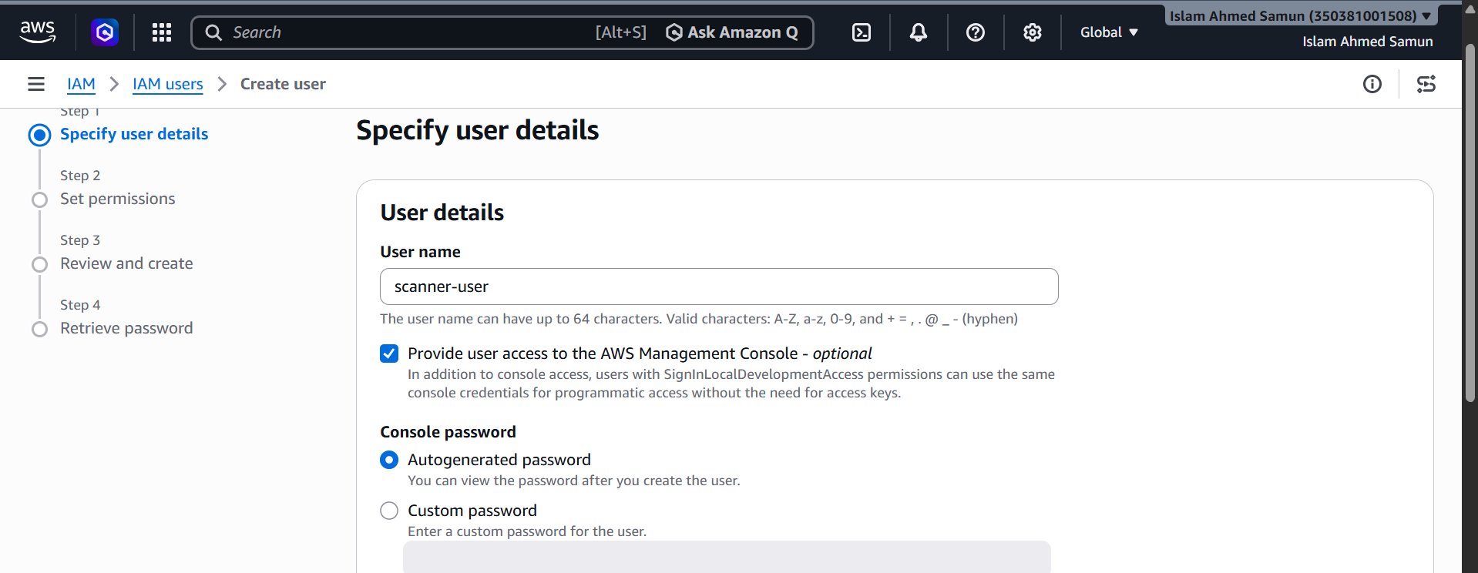

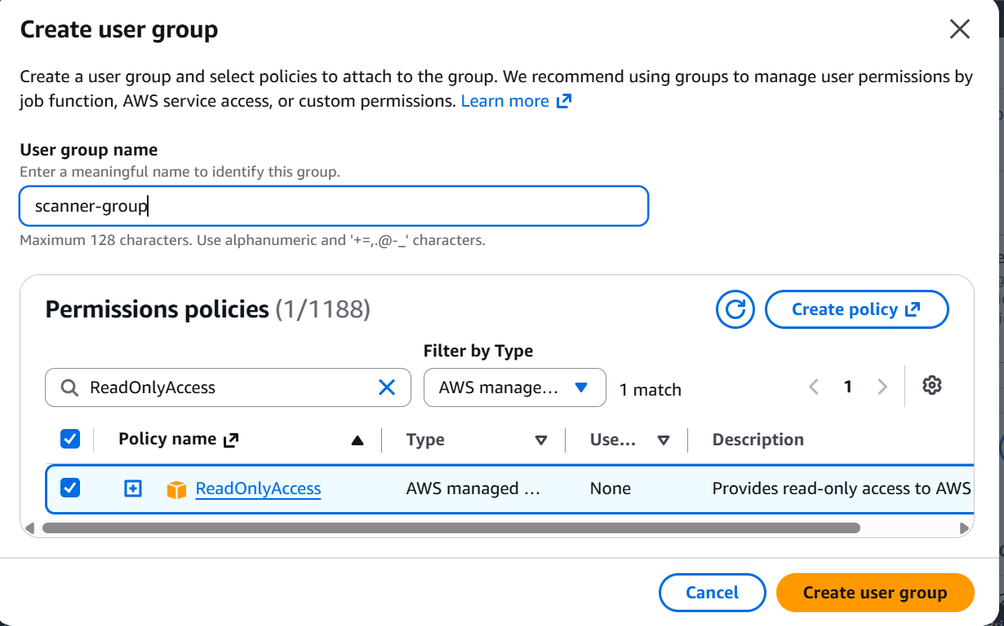

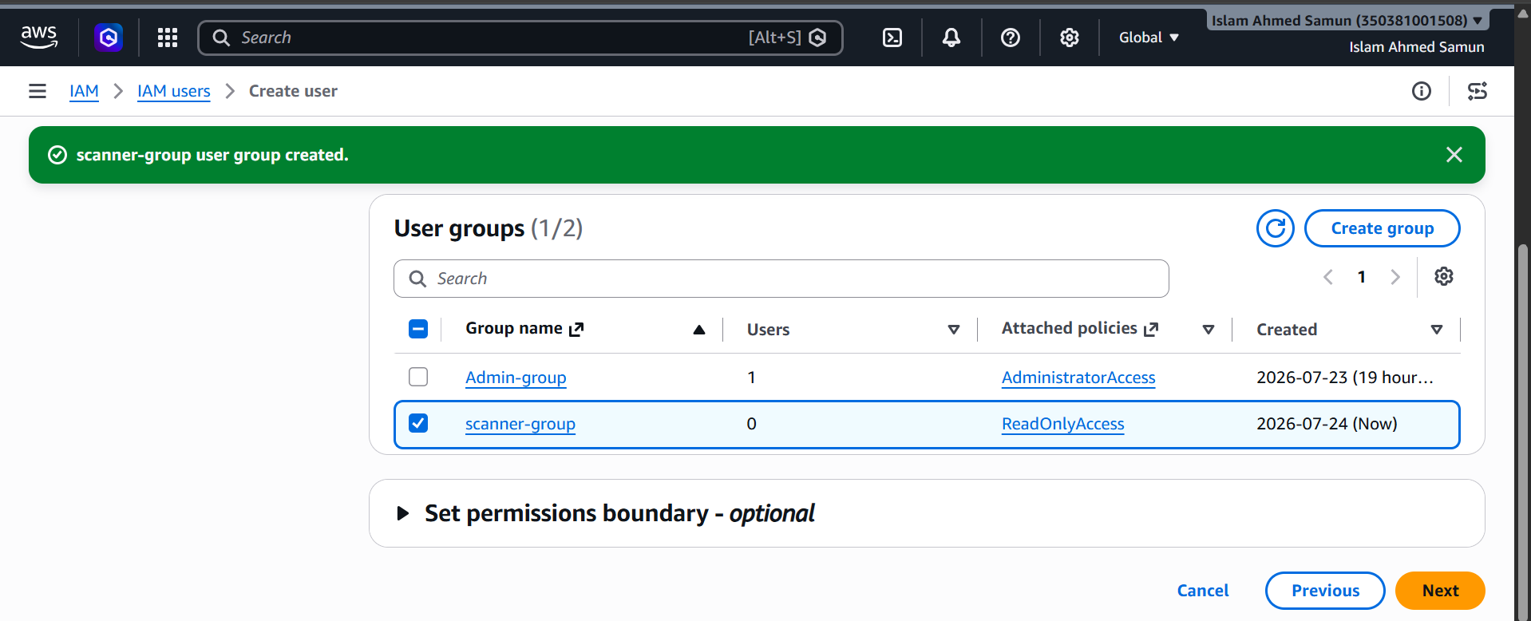
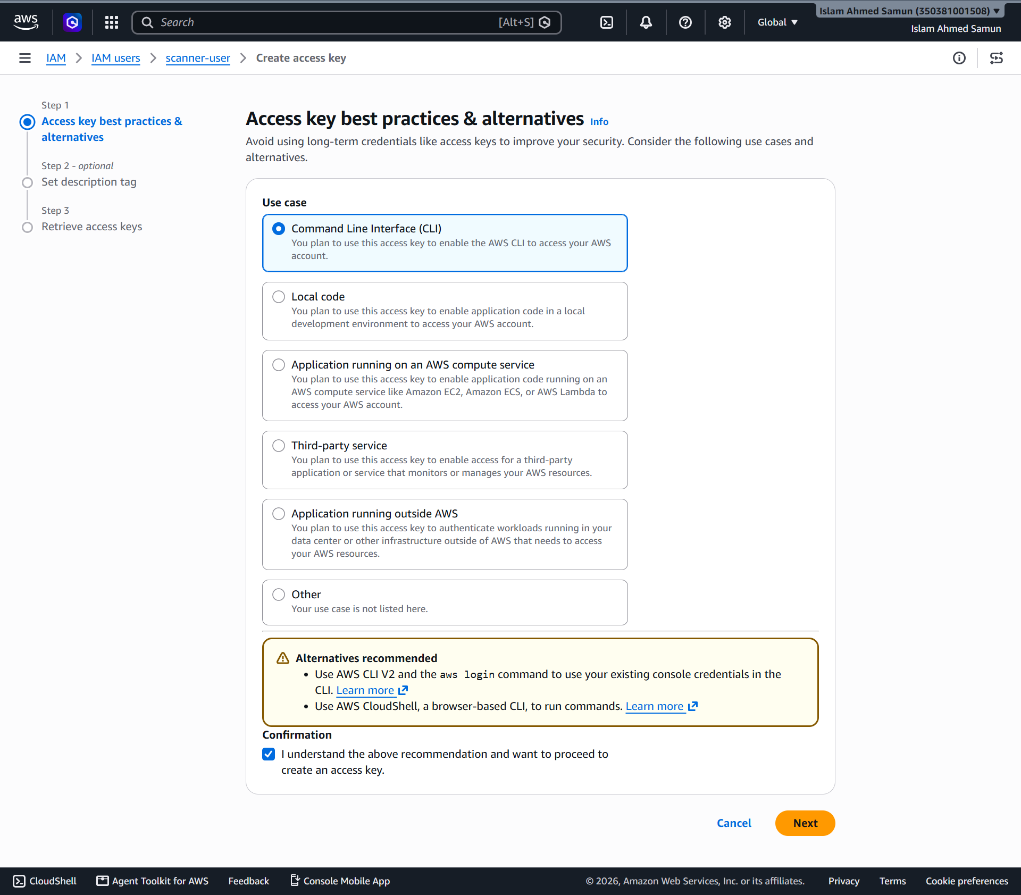
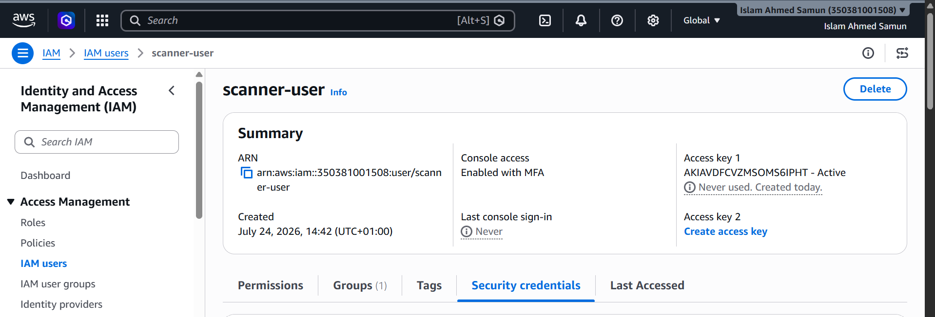

Intentional misconfiguration
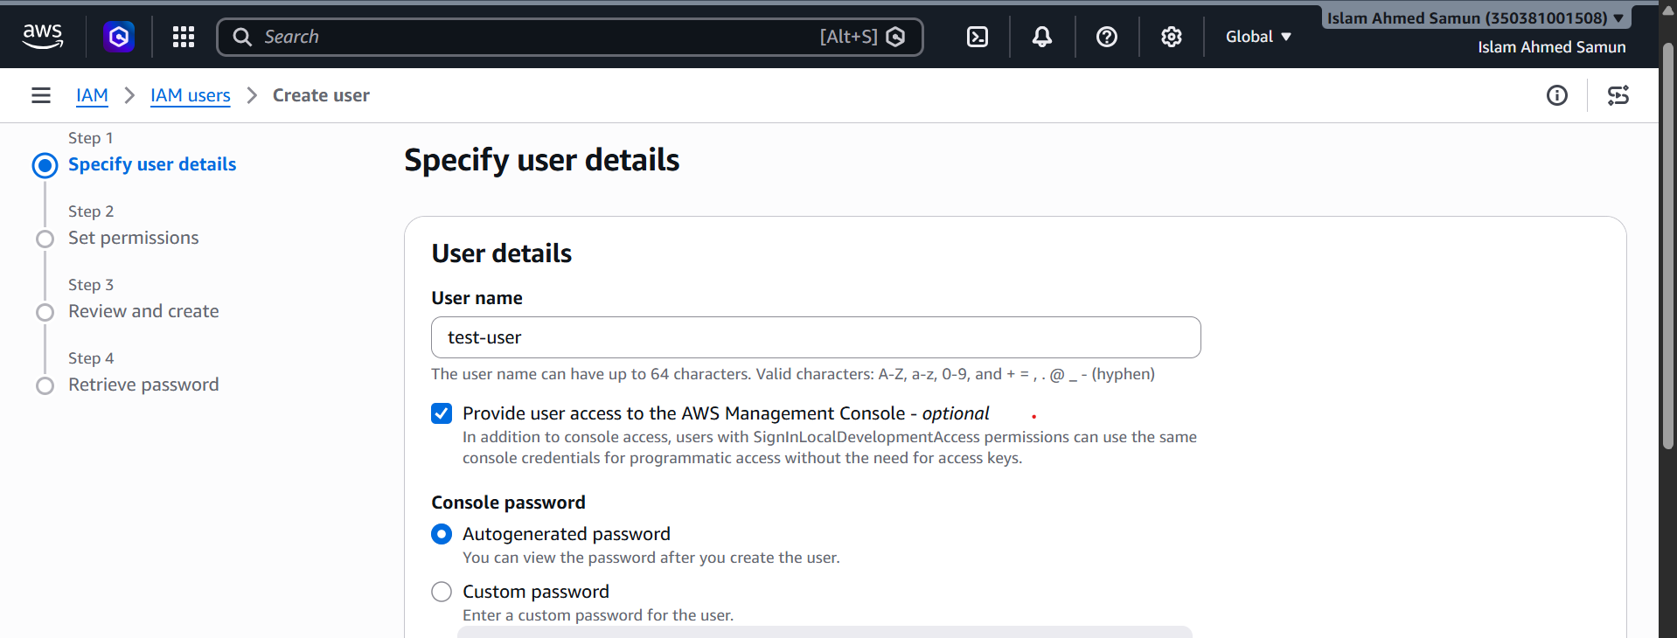

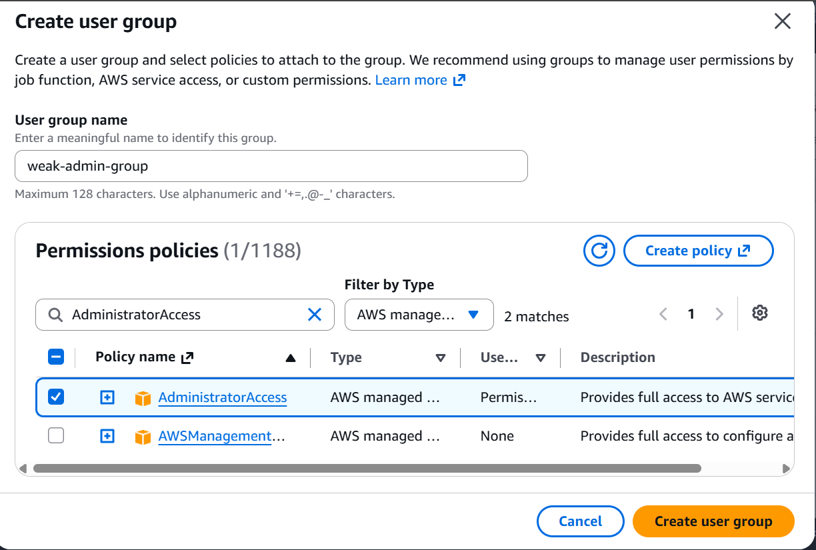

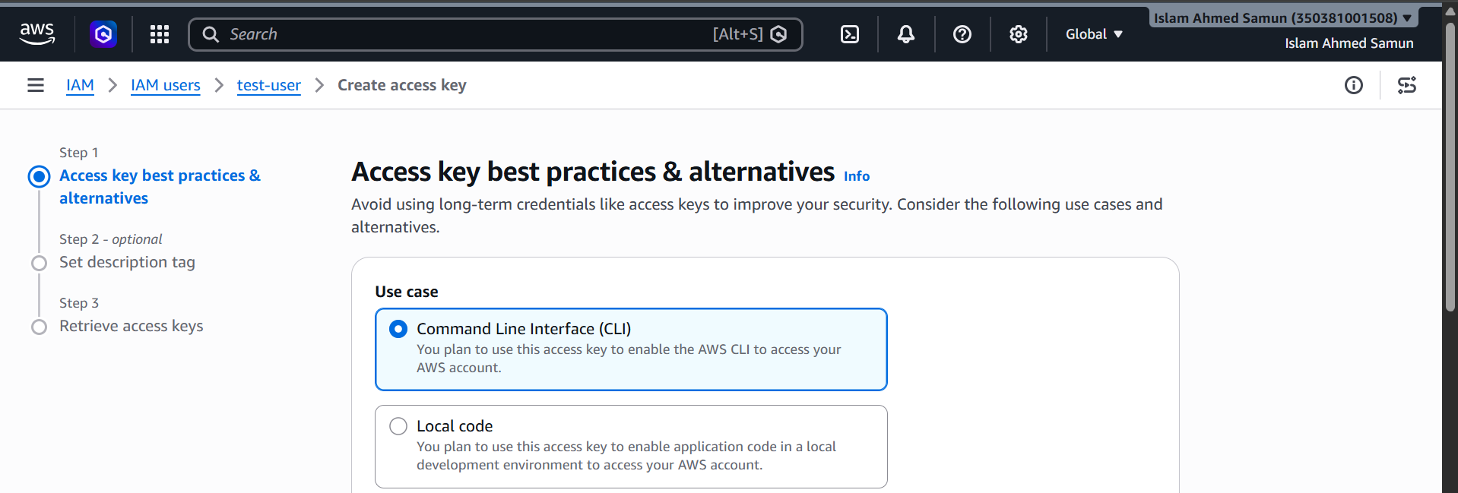

Phase 3 – Create S3 Buckets

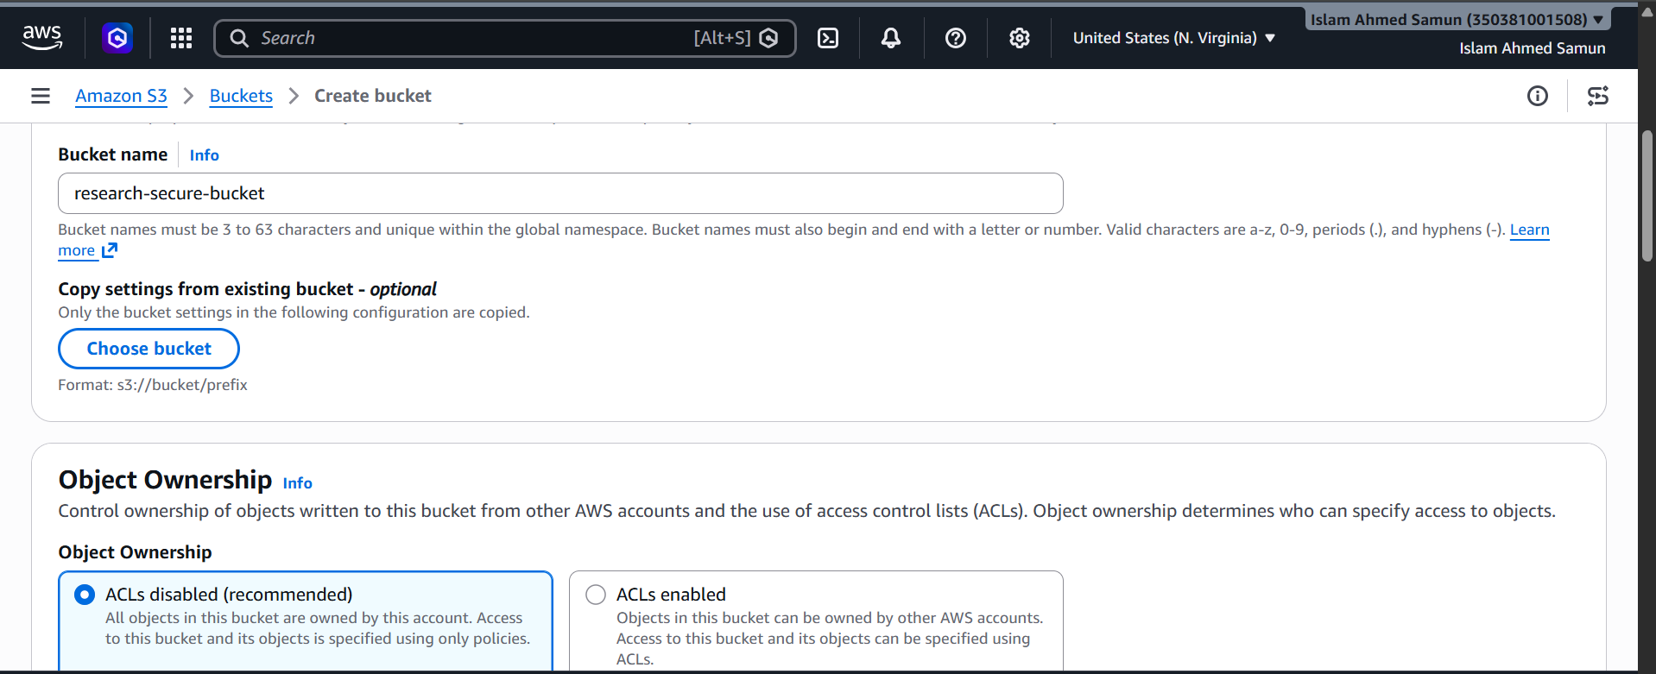

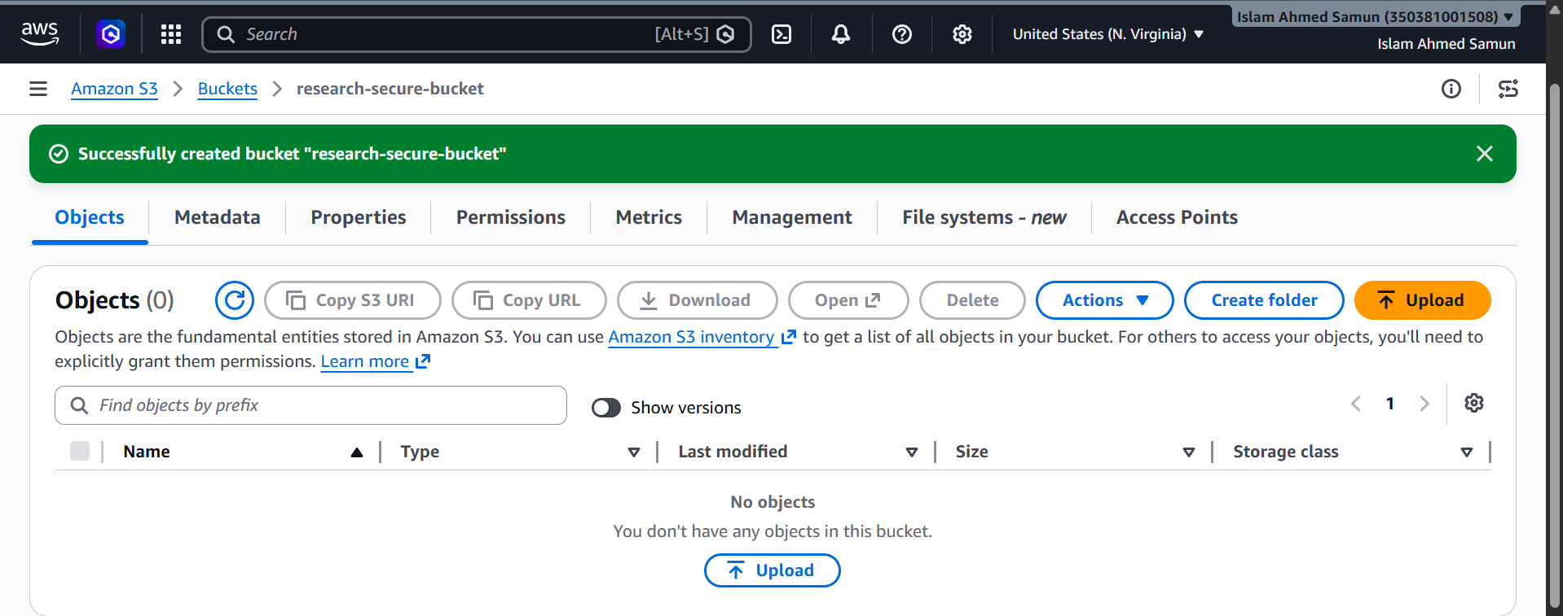

Bucket misconfiguration
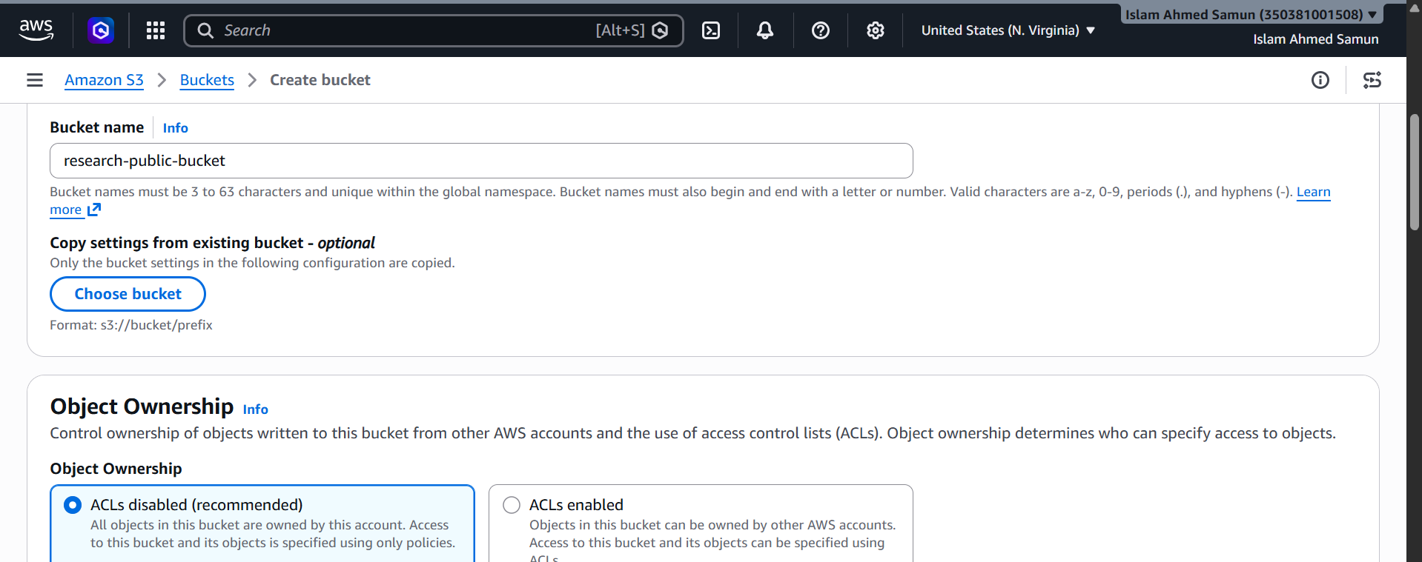

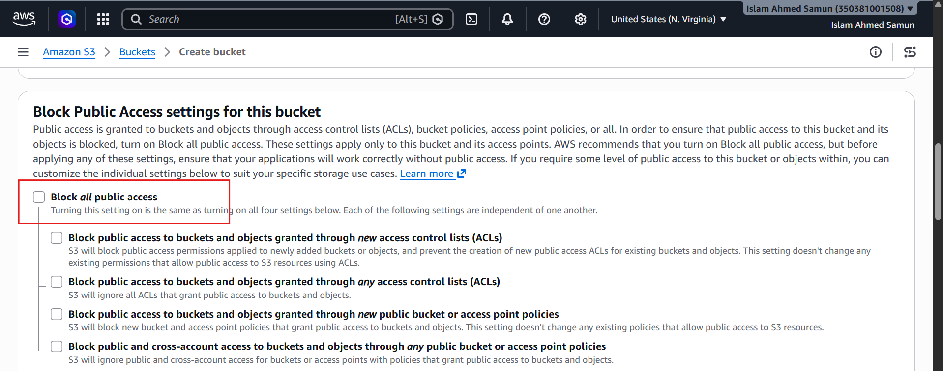

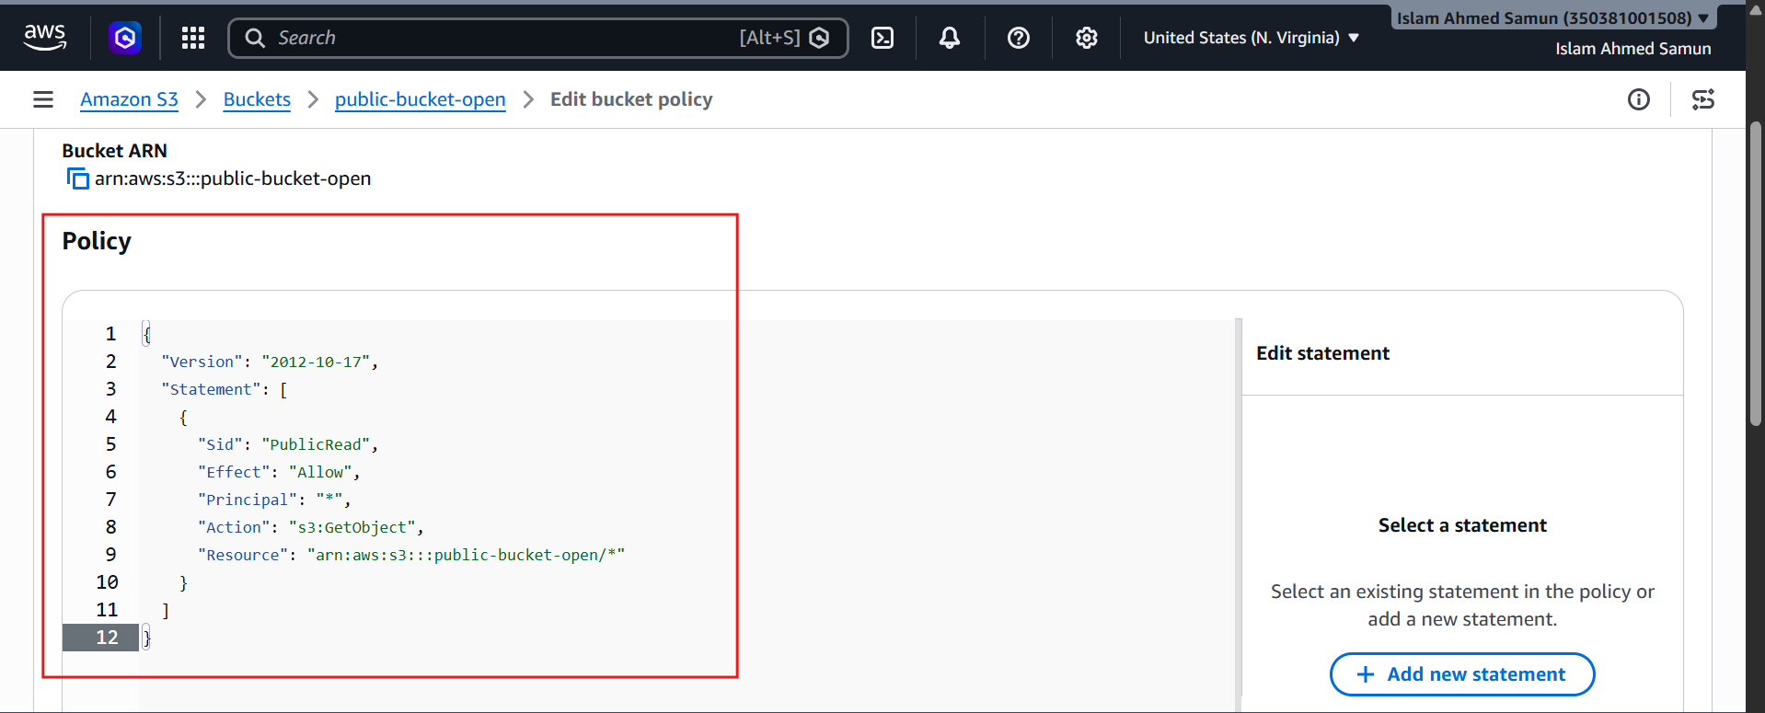

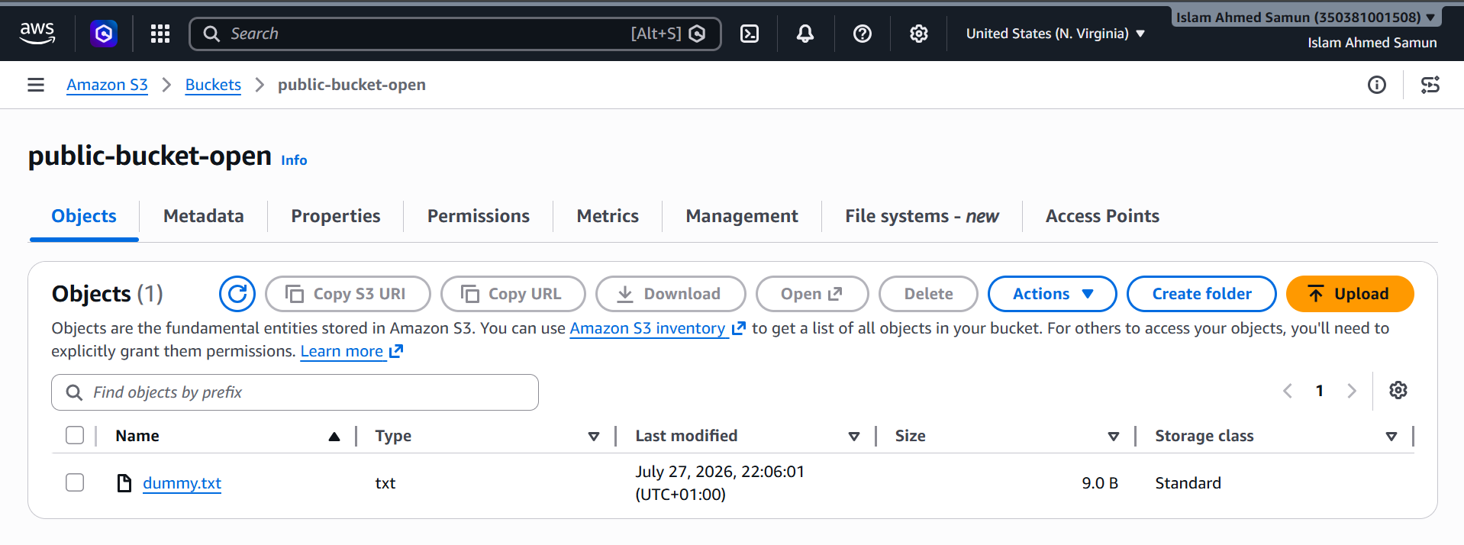

Phase 4 – Create VPC
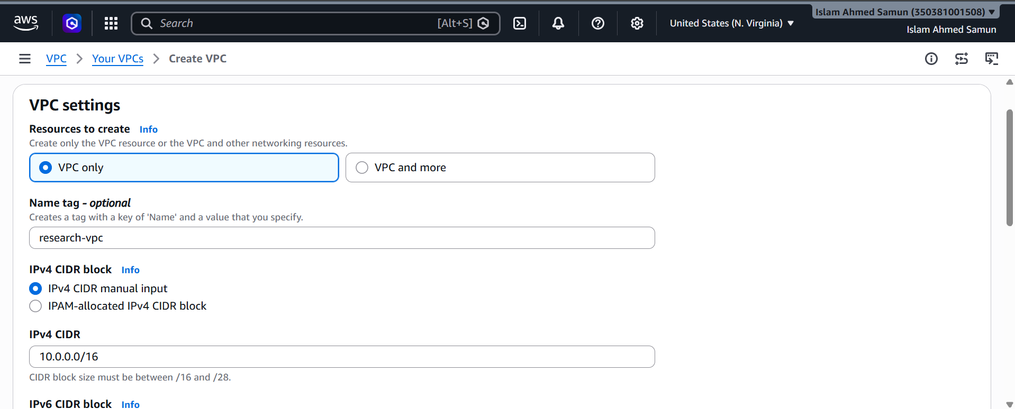

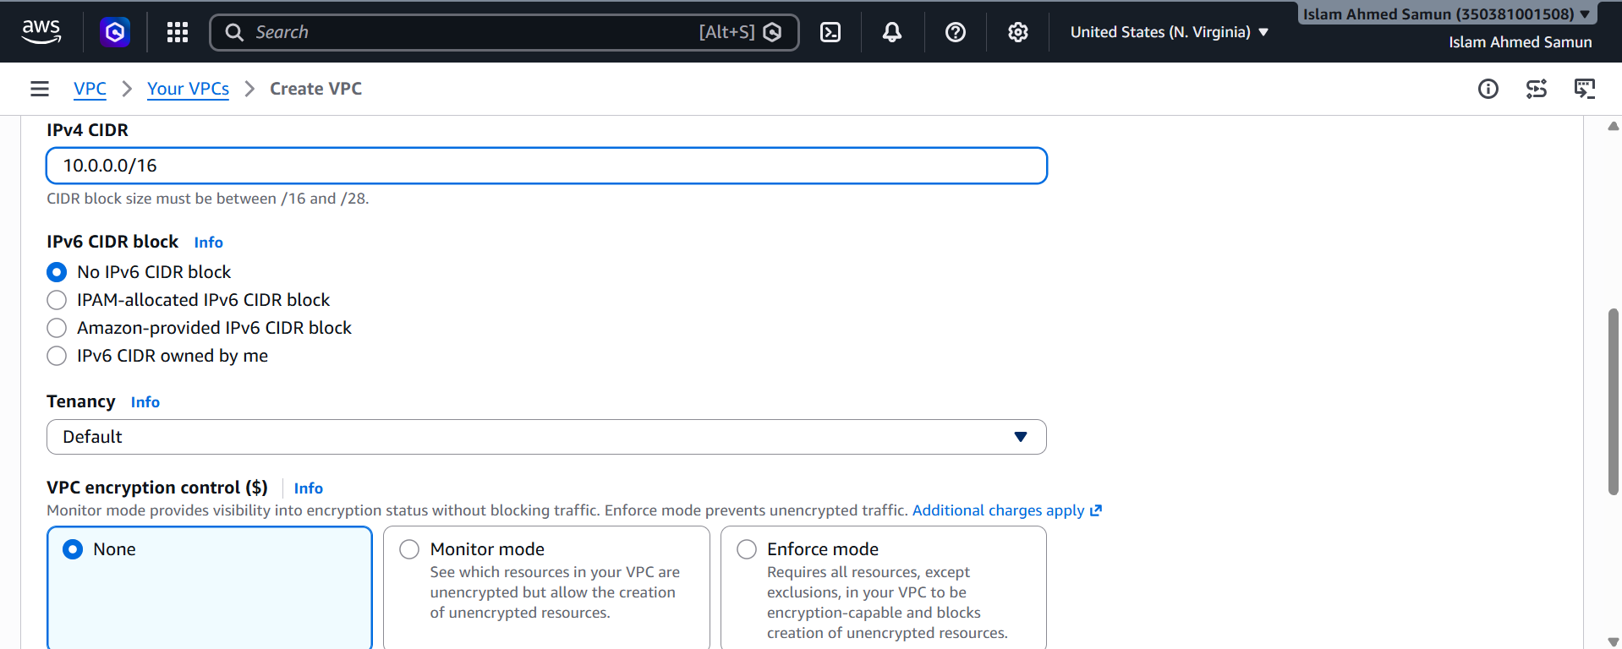

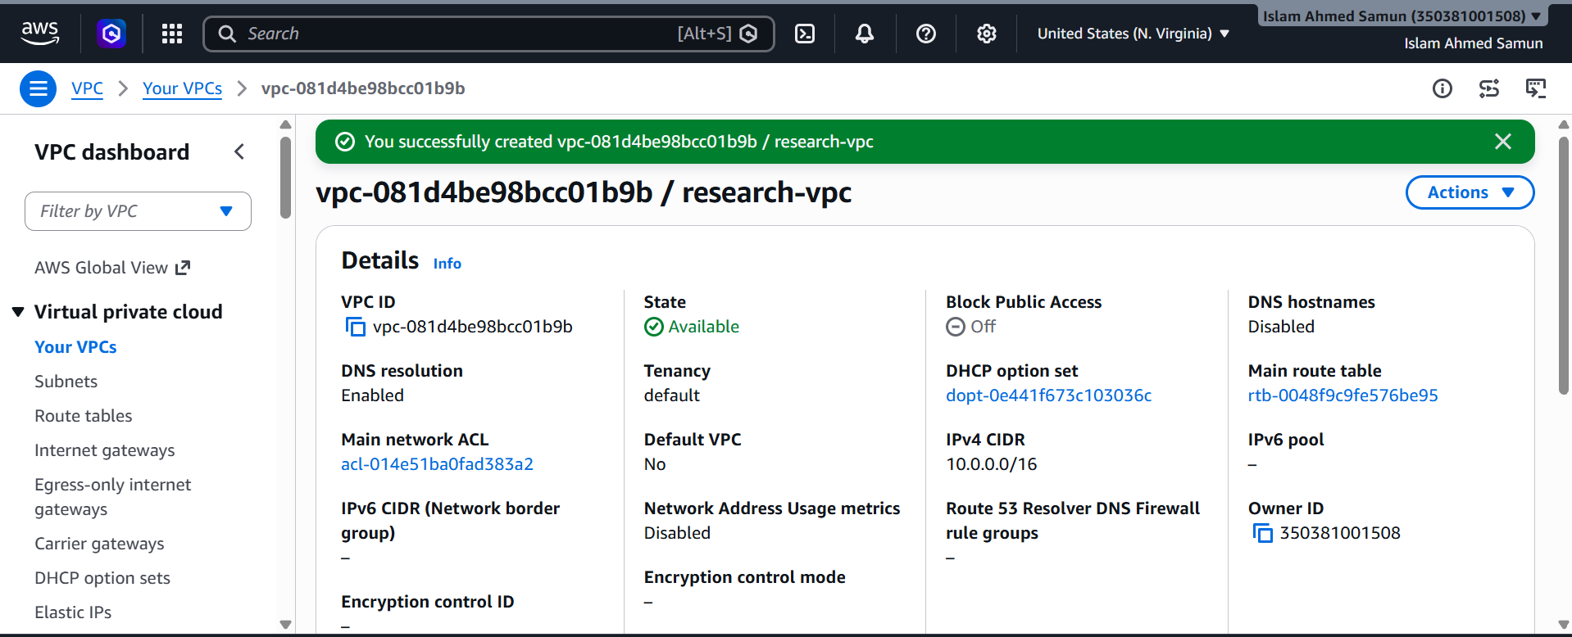

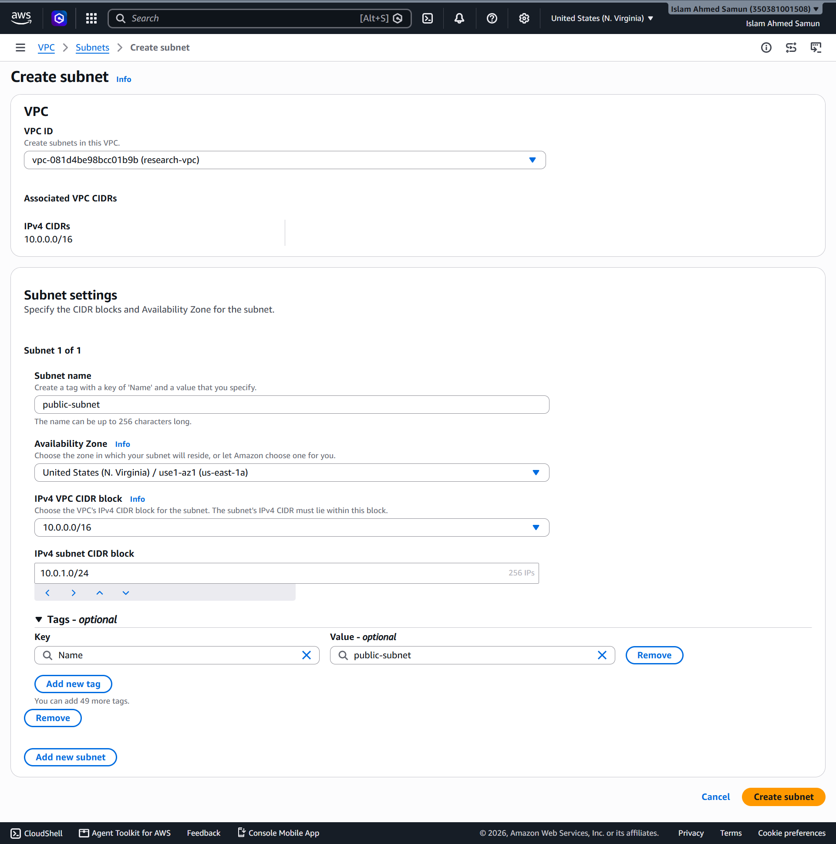

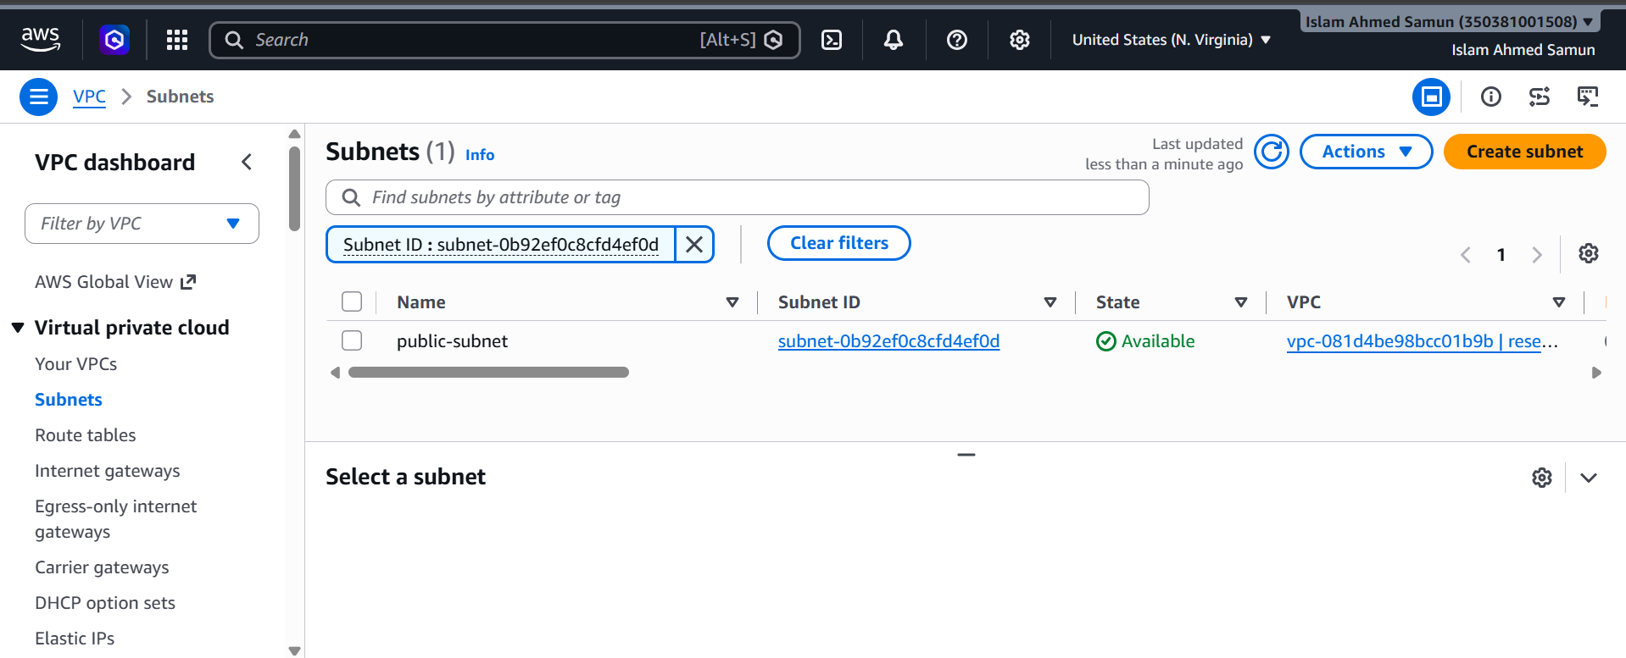

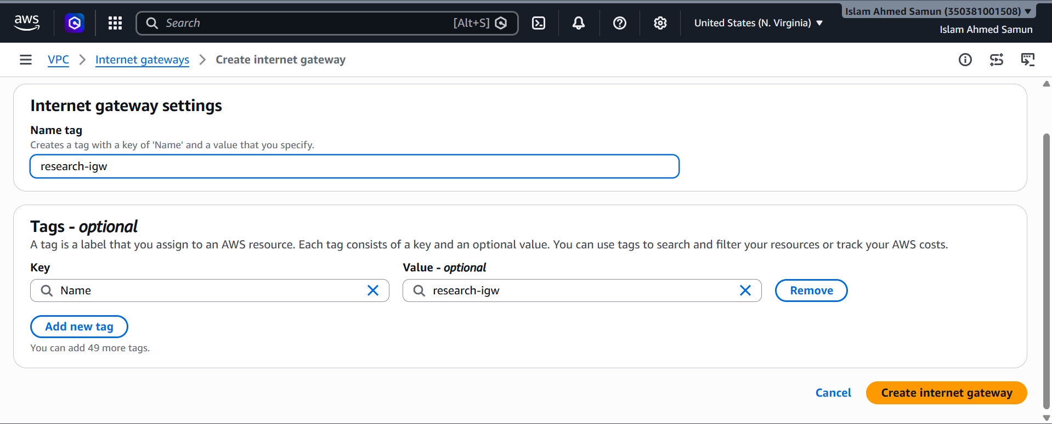

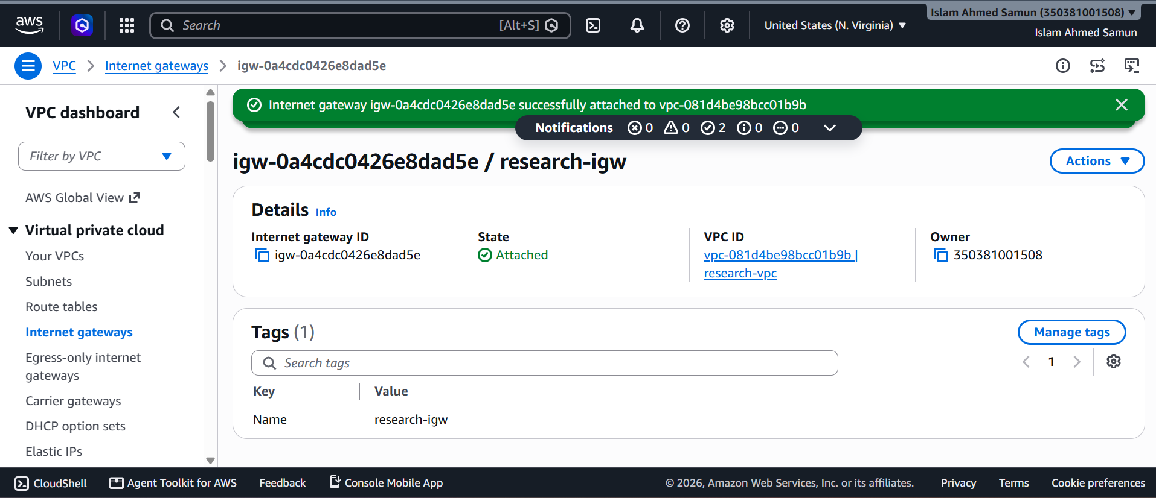

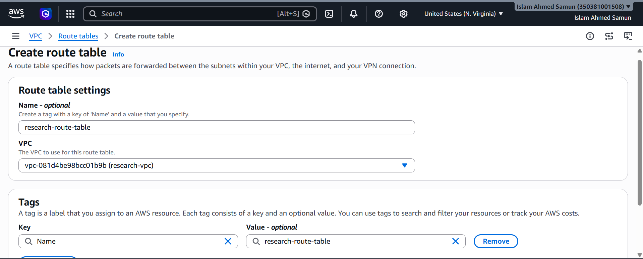

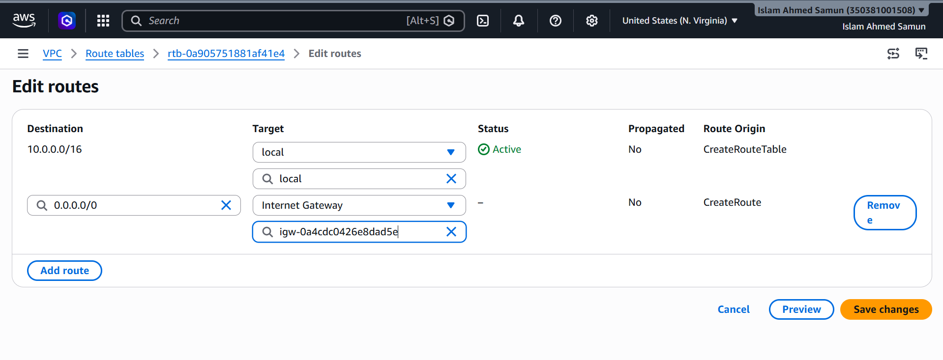

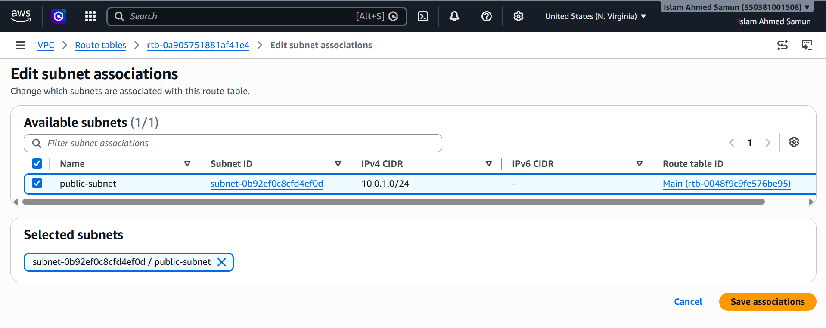

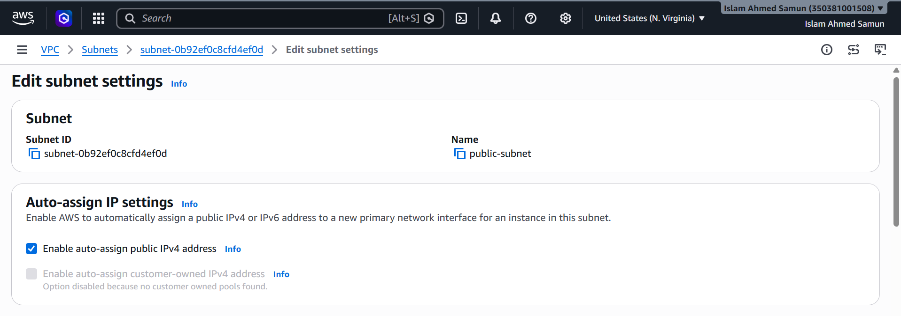

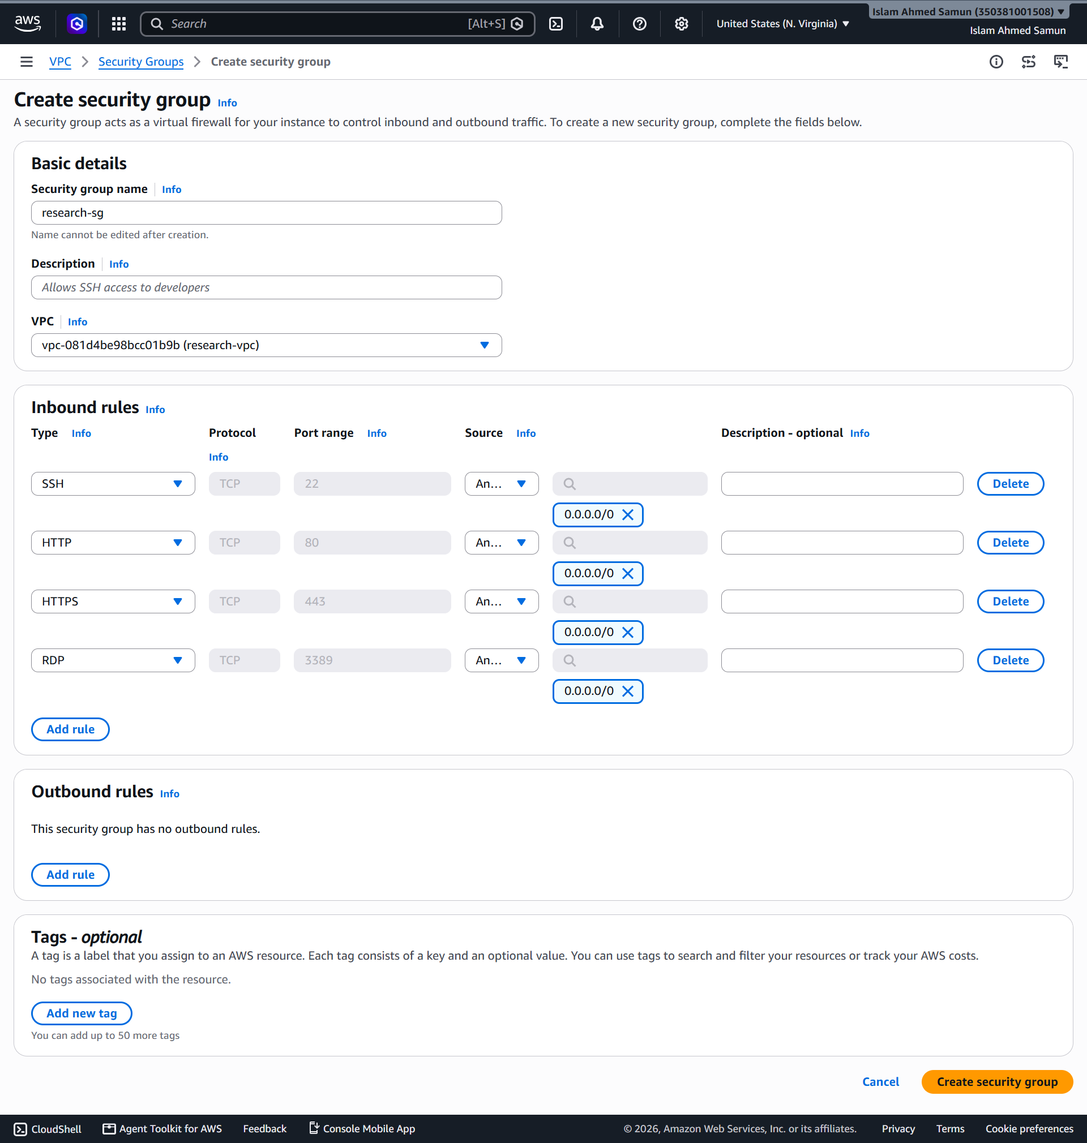

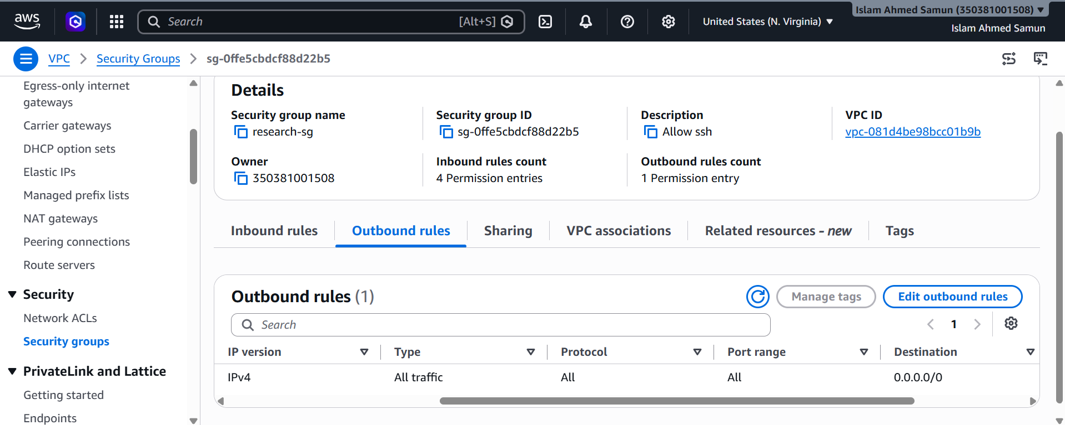

Phase 5 – Launch EC2
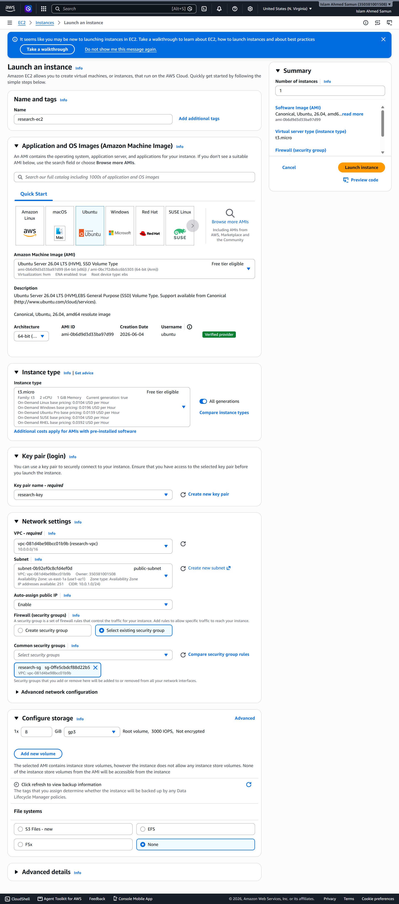
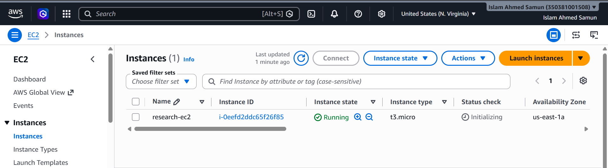

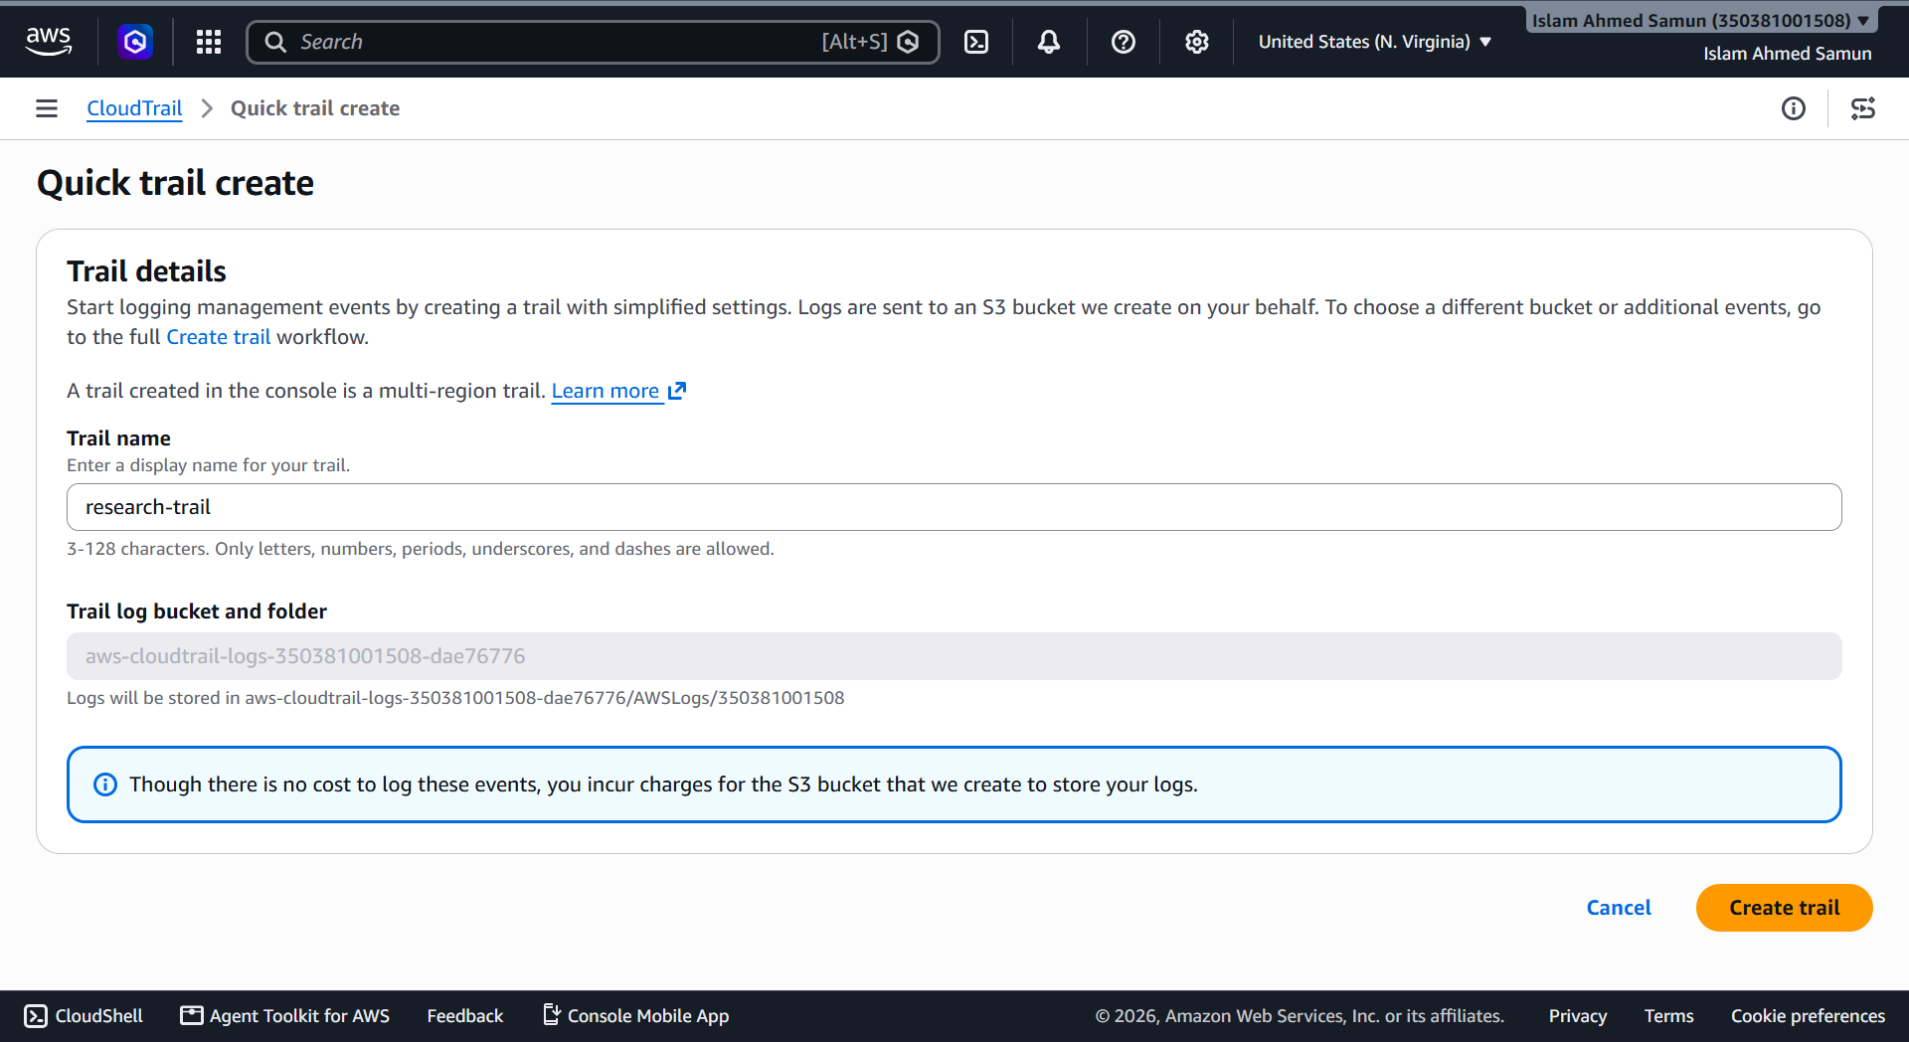

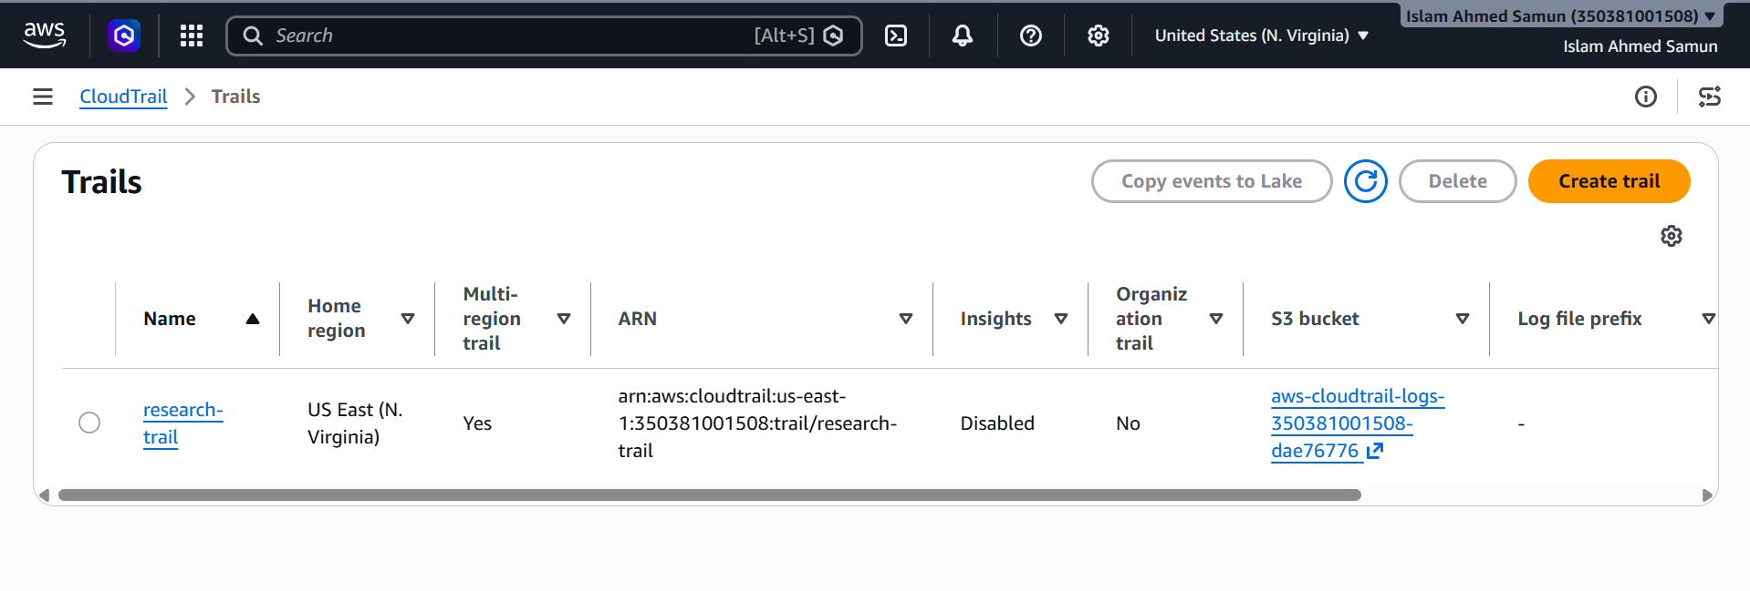
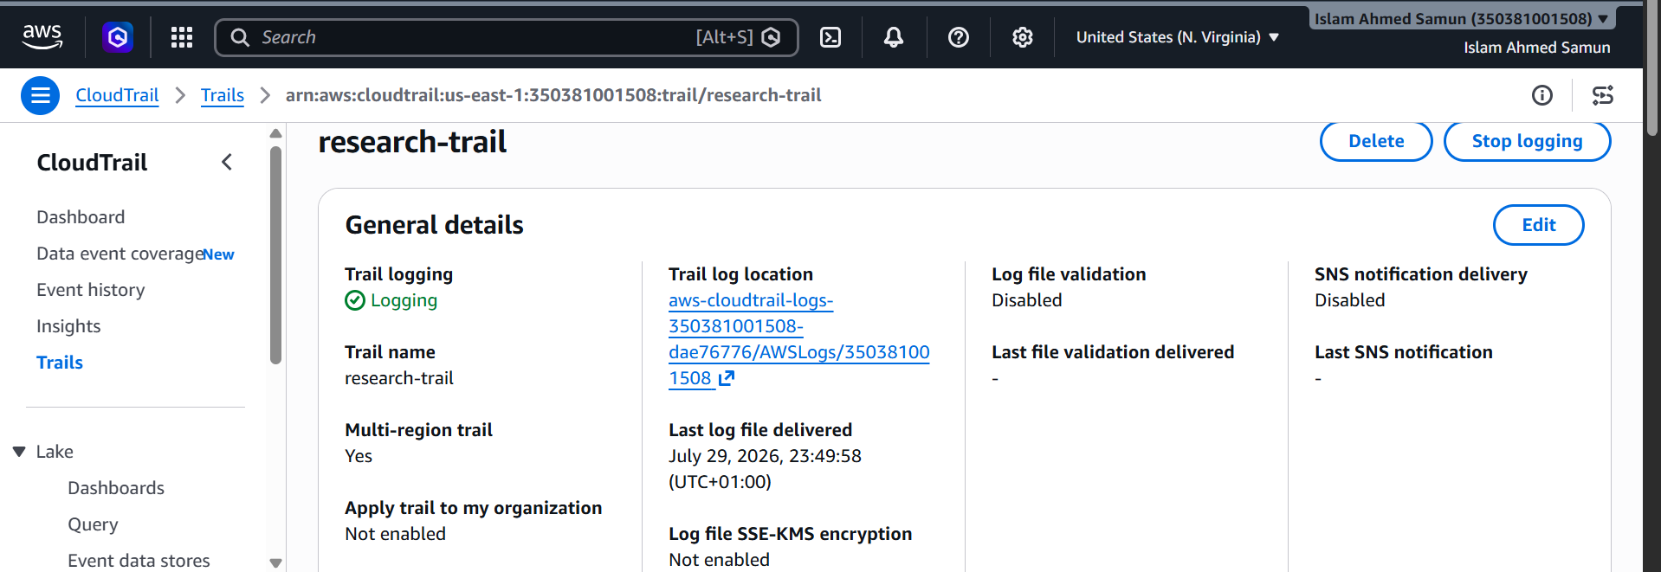

VPC Flow Logs

Configure the AWS CLI
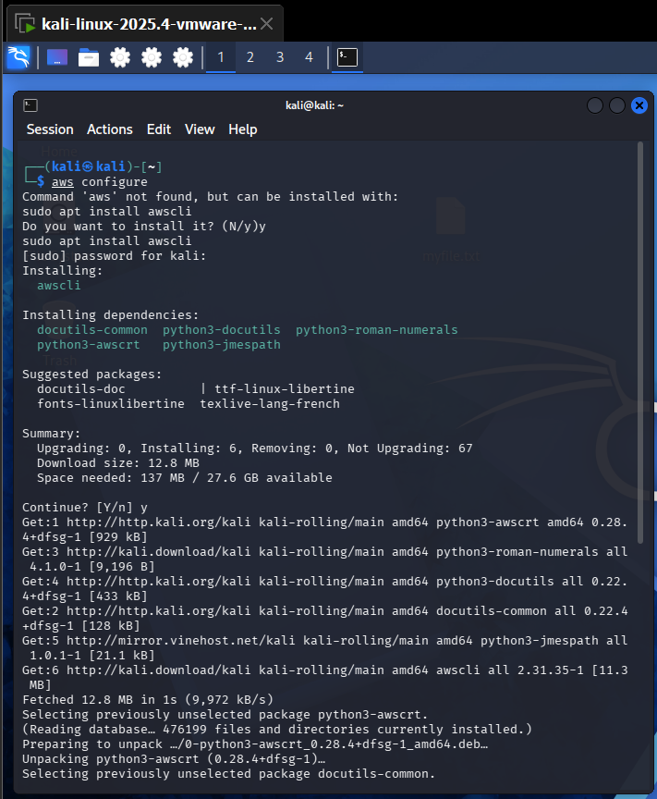
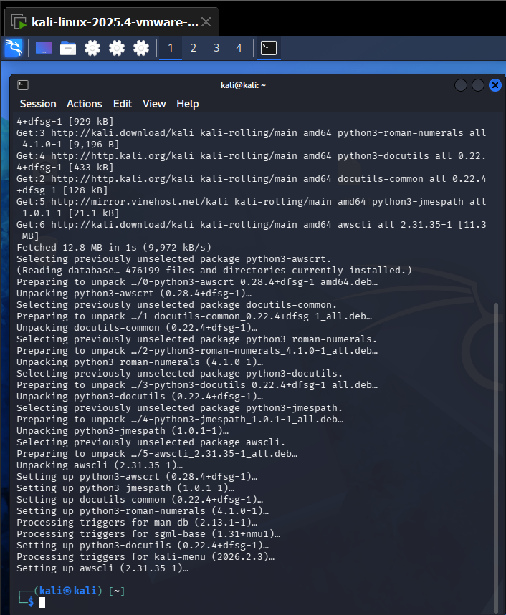

Python installation
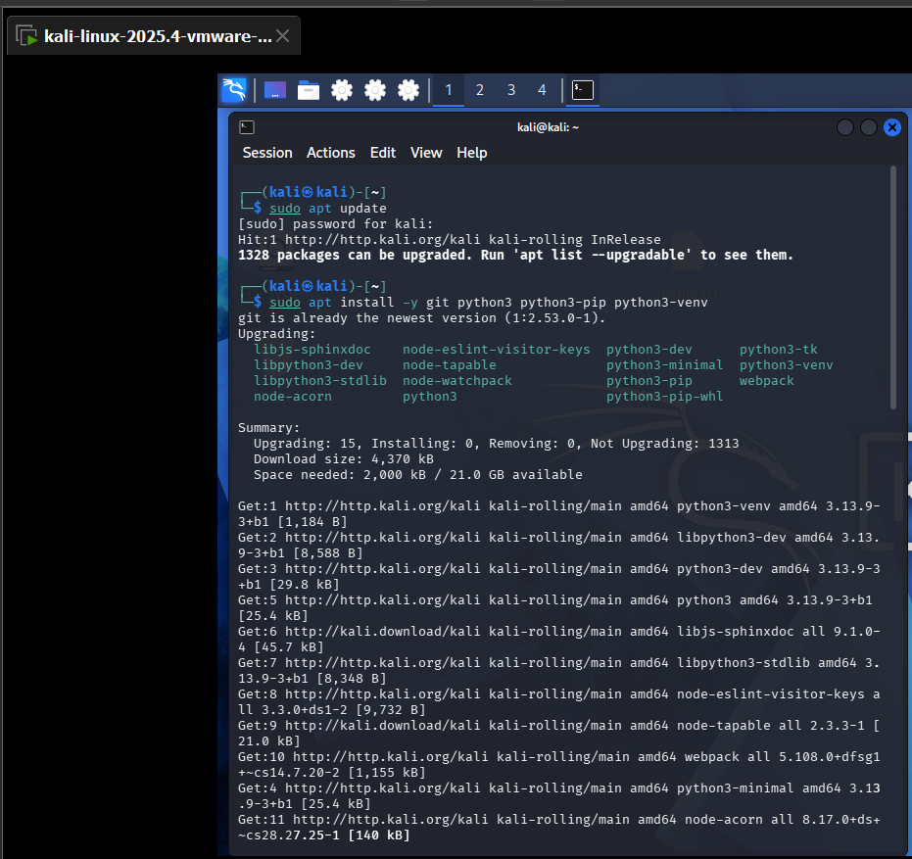

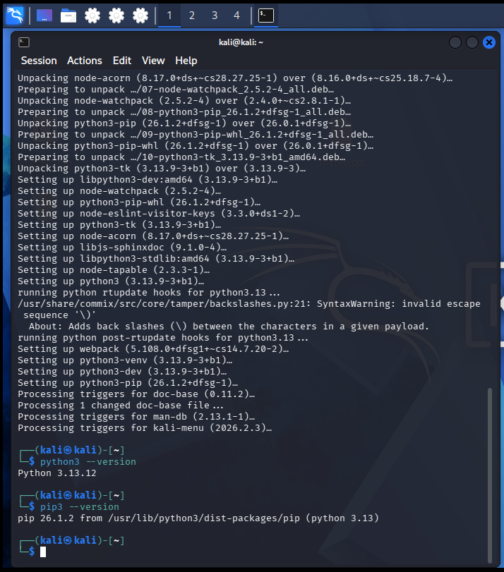

Prowler Installation
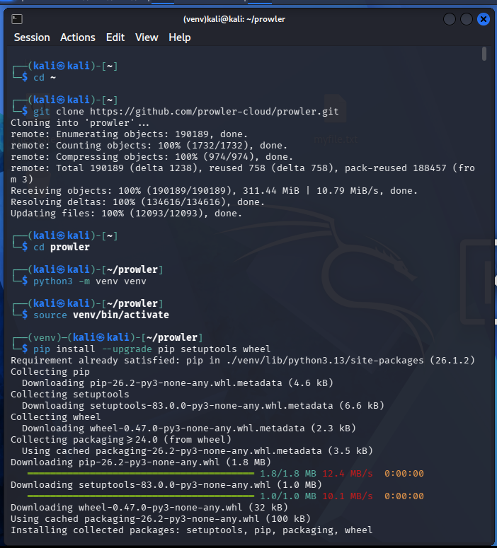
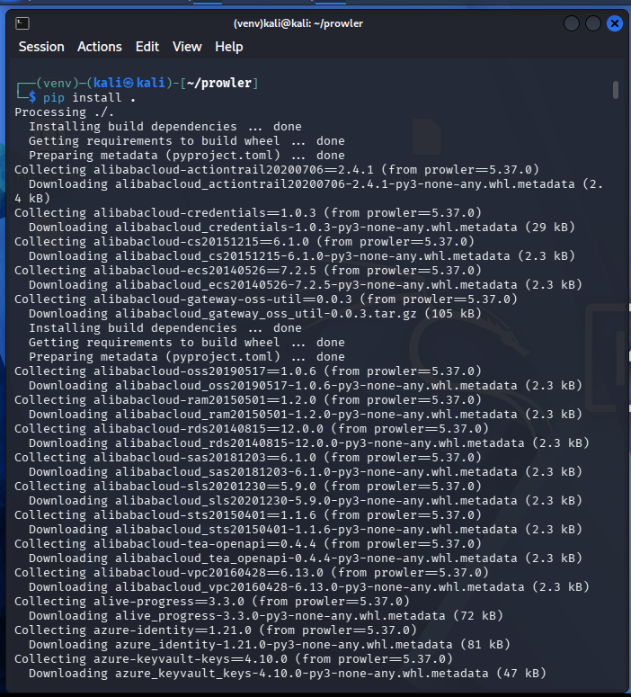

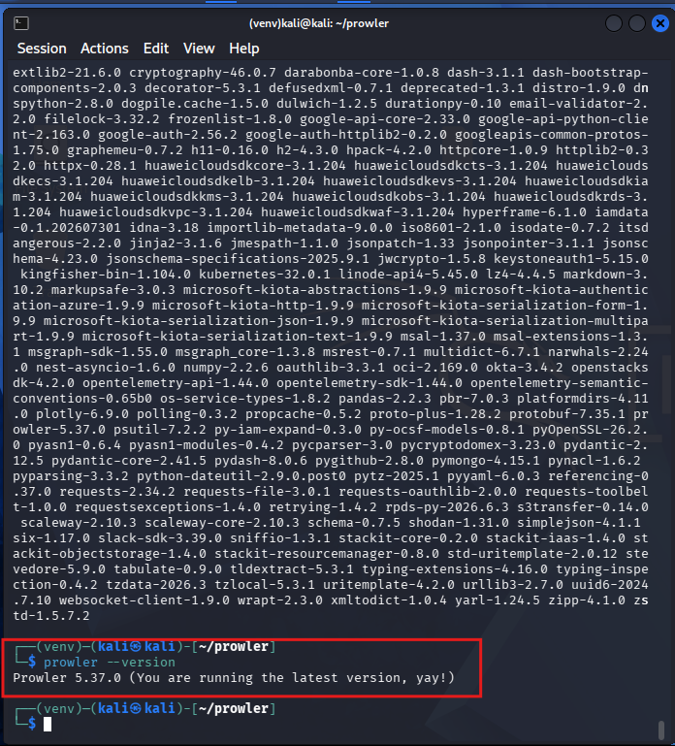

Prowler run and scan on aws controlled environment
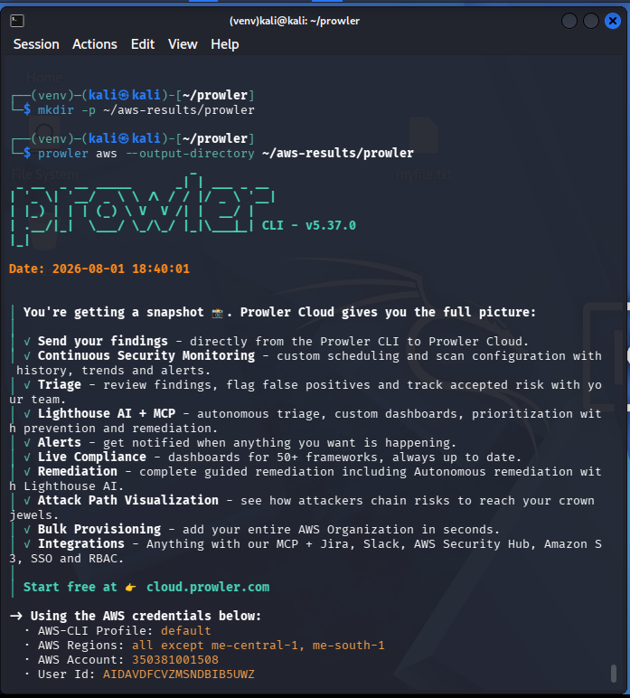

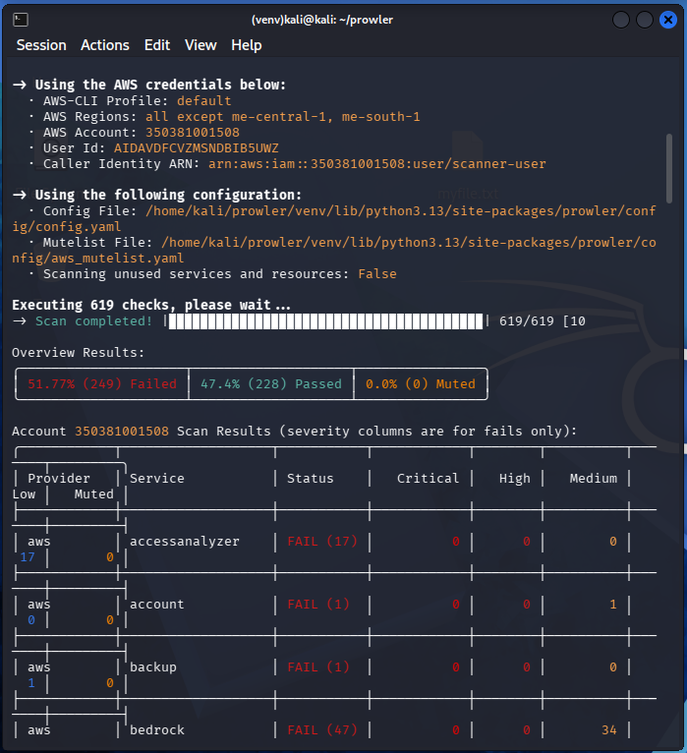

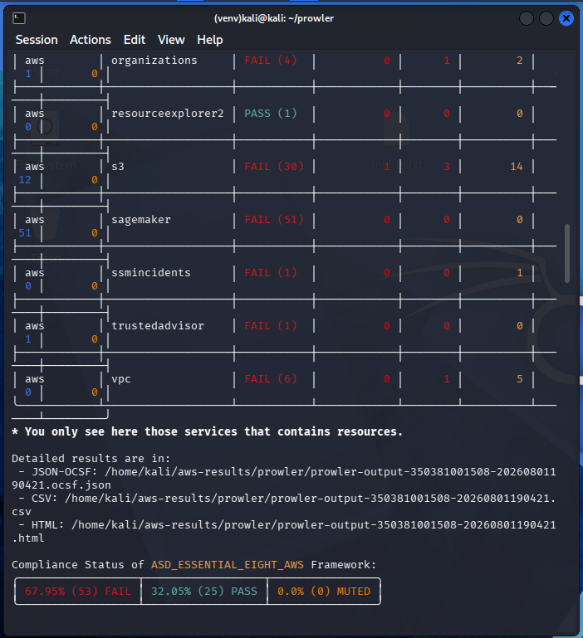

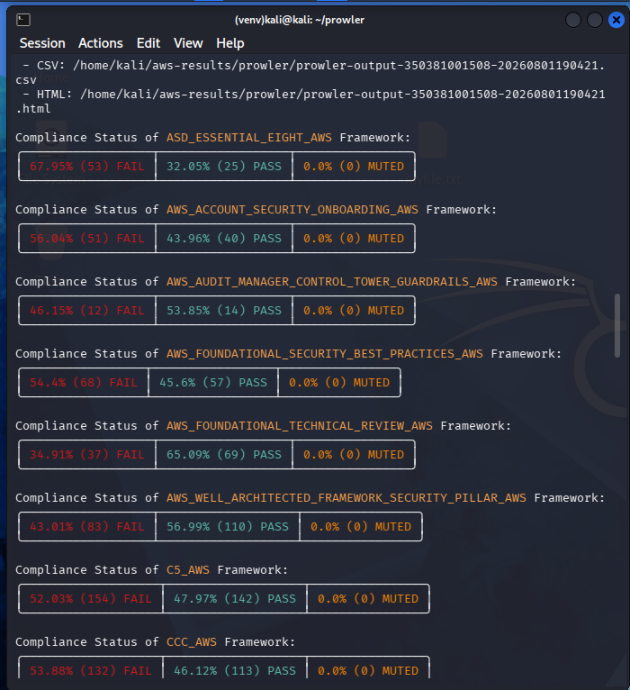

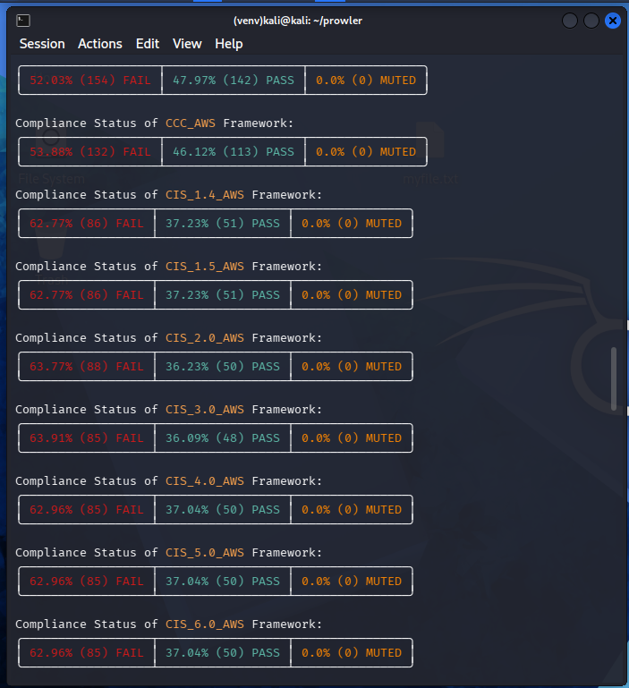

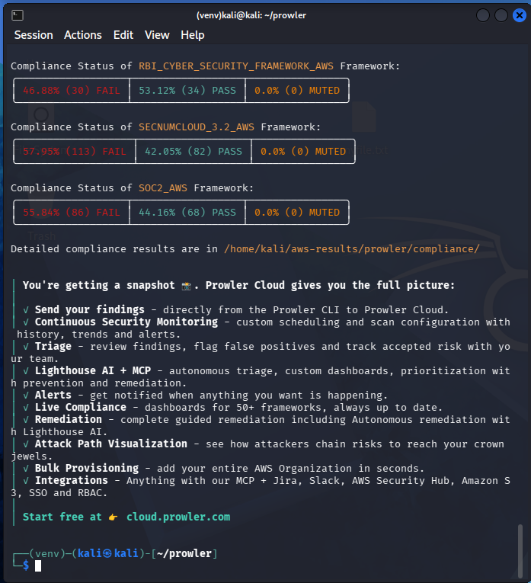

Prowler scanned report
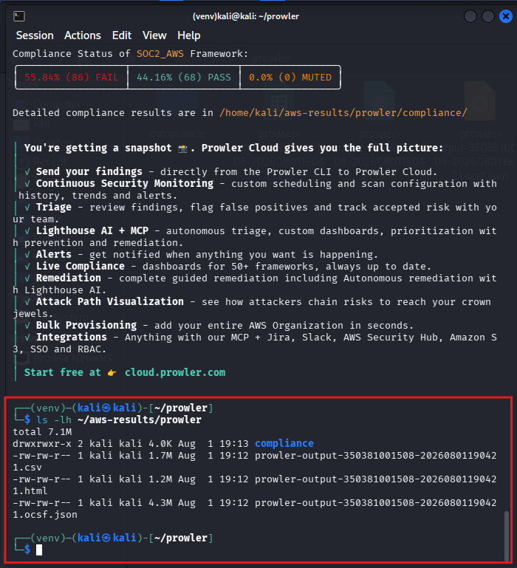
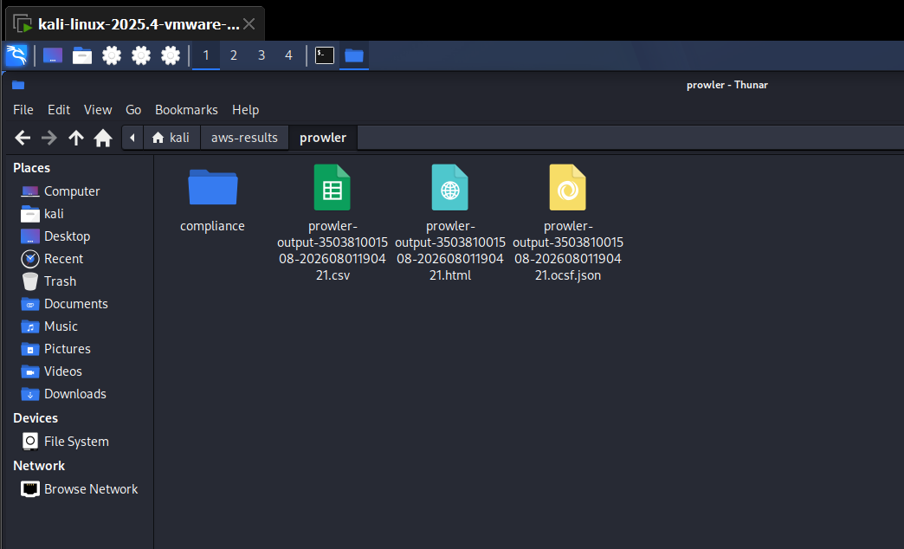

Prowler result
_ __ _ __ _____ _| | ___ _ __
| '_ \| '__/ _ \ \ /\ / / |/ _ \ '__|
| |_) | | | (_) \ V V /| | __/ |
| .__/|_| \___/ \_/\_/ |_|\___|_| CLI - v5.37.0
|_|

Date: 2026-08-01 19:04:21

│ You're getting a snapshot 📸. Prowler Cloud gives you the full picture:
│
│ ✓ Send your findings - directly from the Prowler CLI to Prowler Cloud.
│ ✓ Continuous Security Monitoring - custom scheduling and scan configuration with history, trends and alerts.
│ ✓ Triage - review findings, flag false positives and track accepted risk with your team.
│ ✓ Lighthouse AI + MCP - autonomous triage, custom dashboards, prioritization with prevention and remediation.
│ ✓ Alerts - get notified when anything you want is happening.
│ ✓ Live Compliance - dashboards for 50+ frameworks, always up to date.
│ ✓ Remediation - complete guided remediation including Autonomous remediation with Lighthouse AI.
│ ✓ Attack Path Visualization - see how attackers chain risks to reach your crown jewels.
│ ✓ Bulk Provisioning - add your entire AWS Organization in seconds.
│ ✓ Integrations - Anything with our MCP + Jira, Slack, AWS Security Hub, Amazon S3, SSO and RBAC.
│
│ Start free at 👉 cloud.prowler.com

-> Using the AWS credentials below:
· AWS-CLI Profile: default
· AWS Regions: all except me-central-1, me-south-1
· AWS Account: 350381001508
· User Id: AIDAVDFCVZMSNDBIB5UWZ
· Caller Identity ARN: arn:aws:iam::350381001508:user/scanner-user

-> Using the following configuration:
· Config File: /home/kali/prowler/venv/lib/python3.13/site-packages/prowler/config/config.yaml
· Mutelist File: /home/kali/prowler/venv/lib/python3.13/site-packages/prowler/config/aws_mutelist.yaml
· Scanning unused services and resources: False

Executing 619 checks, please wait...
-> Scan completed! |▉▉▉▉▉▉▉▉▉▉▉▉▉▉▉▉▉▉▉▉▉▉▉▉▉▉▉▉▉▉▉▉▉▉▉▉▉▉▉▉| 619/619 [10

Overview Results:
╭─────────────────────┬────────────────────┬────────────────╮
│ 51.77% (249) Failed │ 47.4% (228) Passed │ 0.0% (0) Muted │
╰─────────────────────┴────────────────────┴────────────────╯

Account 350381001508 Scan Results (severity columns are for fails only):
╭────────────┬───────────────────┬───────────┬────────────┬────────┬──────────┬───────┬─────────╮
│ Provider │ Service │ Status │ Critical │ High │ Medium │ Low │ Muted │
├────────────┼───────────────────┼───────────┼────────────┼────────┼──────────┼───────┼─────────┤
│ aws │ accessanalyzer │ FAIL (17) │ 0 │ 0 │ 0 │ 17 │ 0 │
├────────────┼───────────────────┼───────────┼────────────┼────────┼──────────┼───────┼─────────┤
│ aws │ account │ FAIL (1) │ 0 │ 0 │ 1 │ 0 │ 0 │
├────────────┼───────────────────┼───────────┼────────────┼────────┼──────────┼───────┼─────────┤
│ aws │ backup │ FAIL (1) │ 0 │ 0 │ 0 │ 1 │ 0 │
├────────────┼───────────────────┼───────────┼────────────┼────────┼──────────┼───────┼─────────┤
│ aws │ bedrock │ FAIL (47) │ 0 │ 0 │ 34 │ 13 │ 0 │
├────────────┼───────────────────┼───────────┼────────────┼────────┼──────────┼───────┼─────────┤
│ aws │ cloudtrail │ FAIL (8) │ 0 │ 0 │ 4 │ 4 │ 0 │
├────────────┼───────────────────┼───────────┼────────────┼────────┼──────────┼───────┼─────────┤
│ aws │ cloudwatch │ FAIL (15) │ 0 │ 0 │ 15 │ 0 │ 0 │
├────────────┼───────────────────┼───────────┼────────────┼────────┼──────────┼───────┼─────────┤
│ aws │ config │ FAIL (18) │ 0 │ 1 │ 17 │ 0 │ 0 │
├────────────┼───────────────────┼───────────┼────────────┼────────┼──────────┼───────┼─────────┤
│ aws │ ec2 │ FAIL (20) │ 2 │ 9 │ 8 │ 1 │ 0 │
├────────────┼───────────────────┼───────────┼────────────┼────────┼──────────┼───────┼─────────┤
│ aws │ eventbridge │ PASS (34) │ 0 │ 0 │ 0 │ 0 │ 0 │
├────────────┼───────────────────┼───────────┼────────────┼────────┼──────────┼───────┼─────────┤
│ aws │ fms │ FAIL (1) │ 0 │ 0 │ 1 │ 0 │ 0 │
├────────────┼───────────────────┼───────────┼────────────┼────────┼──────────┼───────┼─────────┤
│ aws │ iam │ FAIL (27) │ 2 │ 8 │ 10 │ 7 │ 0 │
├────────────┼───────────────────┼───────────┼────────────┼────────┼──────────┼───────┼─────────┤
│ aws │ networkfirewall │ FAIL (1) │ 0 │ 0 │ 1 │ 0 │ 0 │
├────────────┼───────────────────┼───────────┼────────────┼────────┼──────────┼───────┼─────────┤
│ aws │ organizations │ FAIL (4) │ 0 │ 1 │ 2 │ 1 │ 0 │
├────────────┼───────────────────┼───────────┼────────────┼────────┼──────────┼───────┼─────────┤
│ aws │ resourceexplorer2 │ PASS (1) │ 0 │ 0 │ 0 │ 0 │ 0 │
├────────────┼───────────────────┼───────────┼────────────┼────────┼──────────┼───────┼─────────┤
│ aws │ s3 │ FAIL (30) │ 1 │ 3 │ 14 │ 12 │ 0 │
├────────────┼───────────────────┼───────────┼────────────┼────────┼──────────┼───────┼─────────┤
│ aws │ sagemaker │ FAIL (51) │ 0 │ 0 │ 0 │ 51 │ 0 │
├────────────┼───────────────────┼───────────┼────────────┼────────┼──────────┼───────┼─────────┤
│ aws │ ssmincidents │ FAIL (1) │ 0 │ 0 │ 1 │ 0 │ 0 │
├────────────┼───────────────────┼───────────┼────────────┼────────┼──────────┼───────┼─────────┤
│ aws │ trustedadvisor │ FAIL (1) │ 0 │ 0 │ 0 │ 1 │ 0 │
├────────────┼───────────────────┼───────────┼────────────┼────────┼──────────┼───────┼─────────┤
│ aws │ vpc │ FAIL (6) │ 0 │ 1 │ 5 │ 0 │ 0 │
╰────────────┴───────────────────┴───────────┴────────────┴────────┴──────────┴───────┴─────────╯
* You only see here those services that contains resources.

Detailed results are in:
- JSON-OCSF: /home/kali/aws-results/prowler/prowler-output-350381001508-20260801190421.ocsf.json
- CSV: /home/kali/aws-results/prowler/prowler-output-350381001508-20260801190421.csv
- HTML: /home/kali/aws-results/prowler/prowler-output-350381001508-20260801190421.html

Compliance Status of ASD_ESSENTIAL_EIGHT_AWS Framework:
╭──────────────────┬──────────────────┬────────────────╮
│ 67.95% (53) FAIL │ 32.05% (25) PASS │ 0.0% (0) MUTED │
╰──────────────────┴──────────────────┴────────────────╯

Compliance Status of AWS_ACCOUNT_SECURITY_ONBOARDING_AWS Framework:
╭──────────────────┬──────────────────┬────────────────╮
│ 56.04% (51) FAIL │ 43.96% (40) PASS │ 0.0% (0) MUTED │
╰──────────────────┴──────────────────┴────────────────╯

Compliance Status of AWS_AUDIT_MANAGER_CONTROL_TOWER_GUARDRAILS_AWS Framework:
╭──────────────────┬──────────────────┬────────────────╮
│ 46.15% (12) FAIL │ 53.85% (14) PASS │ 0.0% (0) MUTED │
╰──────────────────┴──────────────────┴────────────────╯

Compliance Status of AWS_FOUNDATIONAL_SECURITY_BEST_PRACTICES_AWS Framework:
╭─────────────────┬─────────────────┬────────────────╮
│ 54.4% (68) FAIL │ 45.6% (57) PASS │ 0.0% (0) MUTED │
╰─────────────────┴─────────────────┴────────────────╯

Compliance Status of AWS_FOUNDATIONAL_TECHNICAL_REVIEW_AWS Framework:
╭──────────────────┬──────────────────┬────────────────╮
│ 34.91% (37) FAIL │ 65.09% (69) PASS │ 0.0% (0) MUTED │
╰──────────────────┴──────────────────┴────────────────╯

Compliance Status of AWS_WELL_ARCHITECTED_FRAMEWORK_SECURITY_PILLAR_AWS Framework:
╭──────────────────┬───────────────────┬────────────────╮
│ 43.01% (83) FAIL │ 56.99% (110) PASS │ 0.0% (0) MUTED │
╰──────────────────┴───────────────────┴────────────────╯

Compliance Status of C5_AWS Framework:
╭───────────────────┬───────────────────┬────────────────╮
│ 52.03% (154) FAIL │ 47.97% (142) PASS │ 0.0% (0) MUTED │
╰───────────────────┴───────────────────┴────────────────╯

Compliance Status of CCC_AWS Framework:
╭───────────────────┬───────────────────┬────────────────╮
│ 53.88% (132) FAIL │ 46.12% (113) PASS │ 0.0% (0) MUTED │
╰───────────────────┴───────────────────┴────────────────╯

Compliance Status of CIS_1.4_AWS Framework:
╭──────────────────┬──────────────────┬────────────────╮
│ 62.77% (86) FAIL │ 37.23% (51) PASS │ 0.0% (0) MUTED │
╰──────────────────┴──────────────────┴────────────────╯

Compliance Status of CIS_1.5_AWS Framework:
╭──────────────────┬──────────────────┬────────────────╮
│ 62.77% (86) FAIL │ 37.23% (51) PASS │ 0.0% (0) MUTED │
╰──────────────────┴──────────────────┴────────────────╯

Compliance Status of CIS_2.0_AWS Framework:
╭──────────────────┬──────────────────┬────────────────╮
│ 63.77% (88) FAIL │ 36.23% (50) PASS │ 0.0% (0) MUTED │
╰──────────────────┴──────────────────┴────────────────╯

Compliance Status of CIS_3.0_AWS Framework:
╭──────────────────┬──────────────────┬────────────────╮
│ 63.91% (85) FAIL │ 36.09% (48) PASS │ 0.0% (0) MUTED │
╰──────────────────┴──────────────────┴────────────────╯

Compliance Status of CIS_4.0_AWS Framework:
╭──────────────────┬──────────────────┬────────────────╮
│ 62.96% (85) FAIL │ 37.04% (50) PASS │ 0.0% (0) MUTED │
╰──────────────────┴──────────────────┴────────────────╯

Compliance Status of CIS_5.0_AWS Framework:
╭──────────────────┬──────────────────┬────────────────╮
│ 62.96% (85) FAIL │ 37.04% (50) PASS │ 0.0% (0) MUTED │
╰──────────────────┴──────────────────┴────────────────╯

Compliance Status of CIS_6.0_AWS Framework:
╭──────────────────┬──────────────────┬────────────────╮
│ 62.96% (85) FAIL │ 37.04% (50) PASS │ 0.0% (0) MUTED │
╰──────────────────┴──────────────────┴────────────────╯

Compliance Status of CIS_7.0_AWS Framework:
╭──────────────────┬──────────────────┬────────────────╮
│ 57.14% (84) FAIL │ 42.86% (63) PASS │ 0.0% (0) MUTED │
╰──────────────────┴──────────────────┴────────────────╯

Compliance Status of CIS_CONTROLS_8.1 Framework:
╭───────────────────┬───────────────────┬────────────────╮
│ 45.69% (143) FAIL │ 54.31% (170) PASS │ 0.0% (0) MUTED │
╰───────────────────┴───────────────────┴────────────────╯

Compliance Status of CISA_AWS Framework:
╭──────────────────┬──────────────────┬────────────────╮
│ 37.65% (32) FAIL │ 62.35% (53) PASS │ 0.0% (0) MUTED │
╰──────────────────┴──────────────────┴────────────────╯

Compliance Status of CSA_CCM_4.0 Framework:
╭───────────────────┬──────────────────┬────────────────╮
│ 54.74% (104) FAIL │ 45.26% (86) PASS │ 0.0% (0) MUTED │
╰───────────────────┴──────────────────┴────────────────╯

Compliance Status of DORA_2022_2554 Framework:
╭──────────────────┬──────────────────┬────────────────╮
│ 50.0% (116) FAIL │ 50.0% (116) PASS │ 0.0% (0) MUTED │
╰──────────────────┴──────────────────┴────────────────╯

Estado de Cumplimiento de ENS_RD2022_AWS:
╭───────────────────────┬────────────────────┬────────────────╮
│ 44.52% (65) NO CUMPLE │ 55.48% (81) CUMPLE │ 0.0% (0) MUTED │
╰───────────────────────┴────────────────────┴────────────────╯

Compliance Status of FEDRAMP_LOW_REVISION_4_AWS Framework:
╭──────────────────┬──────────────────┬────────────────╮
│ 40.23% (35) FAIL │ 59.77% (52) PASS │ 0.0% (0) MUTED │
╰──────────────────┴──────────────────┴────────────────╯

Compliance Status of FEDRAMP_MODERATE_REVISION_4_AWS Framework:
╭──────────────────┬──────────────────┬────────────────╮
│ 41.38% (36) FAIL │ 58.62% (51) PASS │ 0.0% (0) MUTED │
╰──────────────────┴──────────────────┴────────────────╯

Compliance Status of FFIEC_AWS Framework:
╭──────────────────┬──────────────────┬────────────────╮
│ 43.53% (37) FAIL │ 56.47% (48) PASS │ 0.0% (0) MUTED │
╰──────────────────┴──────────────────┴────────────────╯

Compliance Status of GDPR_AWS Framework:
╭──────────────────┬──────────────────┬────────────────╮
│ 53.93% (48) FAIL │ 46.07% (41) PASS │ 0.0% (0) MUTED │
╰──────────────────┴──────────────────┴────────────────╯

Compliance Status of GXP_21_CFR_PART_11_AWS Framework:
╭──────────────────┬──────────────────┬────────────────╮
│ 42.17% (35) FAIL │ 57.83% (48) PASS │ 0.0% (0) MUTED │
╰──────────────────┴──────────────────┴────────────────╯

Compliance Status of GXP_EU_ANNEX_11_AWS Framework:
╭──────────────────┬──────────────────┬────────────────╮
│ 53.33% (24) FAIL │ 46.67% (21) PASS │ 0.0% (0) MUTED │
╰──────────────────┴──────────────────┴────────────────╯

Compliance Status of HIPAA_AWS Framework:
╭─────────────────┬─────────────────┬────────────────╮
│ 53.4% (55) FAIL │ 46.6% (48) PASS │ 0.0% (0) MUTED │
╰─────────────────┴─────────────────┴────────────────╯

Compliance Status of ISO27001_2013_AWS Framework:
╭─────────────────┬─────────────────┬────────────────╮
│ 59.3% (51) FAIL │ 40.7% (35) PASS │ 0.0% (0) MUTED │
╰─────────────────┴─────────────────┴────────────────╯

Compliance Status of ISO27001_2022_AWS Framework:
╭───────────────────┬───────────────────┬────────────────╮
│ 51.34% (134) FAIL │ 48.66% (127) PASS │ 0.0% (0) MUTED │
╰───────────────────┴───────────────────┴────────────────╯

Compliance Status of KISA_ISMS_P_2023_AWS Framework:
╭───────────────────┬───────────────────┬────────────────╮
│ 48.37% (193) FAIL │ 51.63% (206) PASS │ 0.0% (0) MUTED │
╰───────────────────┴───────────────────┴────────────────╯

Compliance Status of KISA_ISMS_P_2023_KOREAN_AWS Framework:
╭───────────────────┬───────────────────┬────────────────╮
│ 48.37% (193) FAIL │ 51.63% (206) PASS │ 0.0% (0) MUTED │
╰───────────────────┴───────────────────┴────────────────╯

Compliance Status of MITRE_ATTACK_AWS Framework:
╭──────────────────┬──────────────────┬────────────────╮
│ 56.62% (77) FAIL │ 43.38% (59) PASS │ 0.0% (0) MUTED │
╰──────────────────┴──────────────────┴────────────────╯

Compliance Status of NIS2_AWS Framework:
╭───────────────────┬──────────────────┬────────────────╮
│ 61.21% (101) FAIL │ 38.79% (64) PASS │ 0.0% (0) MUTED │
╰───────────────────┴──────────────────┴────────────────╯

Compliance Status of NIST_800_171_REVISION_2_AWS Framework:
╭──────────────────┬──────────────────┬────────────────╮
│ 48.31% (43) FAIL │ 51.69% (46) PASS │ 0.0% (0) MUTED │
╰──────────────────┴──────────────────┴────────────────╯

Compliance Status of NIST_800_53_REVISION_4_AWS Framework:
╭──────────────────┬──────────────────┬────────────────╮
│ 42.53% (37) FAIL │ 57.47% (50) PASS │ 0.0% (0) MUTED │
╰──────────────────┴──────────────────┴────────────────╯

Compliance Status of NIST_800_53_REVISION_5_AWS Framework:
╭─────────────────┬─────────────────┬────────────────╮
│ 42.7% (38) FAIL │ 57.3% (51) PASS │ 0.0% (0) MUTED │
╰─────────────────┴─────────────────┴────────────────╯

Compliance Status of NIST_CSF_1.1_AWS Framework:
╭──────────────────┬──────────────────┬────────────────╮
│ 54.55% (60) FAIL │ 45.45% (50) PASS │ 0.0% (0) MUTED │
╰──────────────────┴──────────────────┴────────────────╯

Compliance Status of NIST_CSF_2.0_AWS Framework:
╭───────────────────┬───────────────────┬────────────────╮
│ 48.18% (106) FAIL │ 51.82% (114) PASS │ 0.0% (0) MUTED │
╰───────────────────┴───────────────────┴────────────────╯

Compliance Status of PCI_3.2.1_AWS Framework:
╭──────────────────┬──────────────────┬────────────────╮
│ 58.06% (54) FAIL │ 41.94% (39) PASS │ 0.0% (0) MUTED │
╰──────────────────┴──────────────────┴────────────────╯

Compliance Status of PCI_4.0_AWS Framework:
╭──────────────────┬──────────────────┬────────────────╮
│ 50.52% (49) FAIL │ 49.48% (48) PASS │ 0.0% (0) MUTED │
╰──────────────────┴──────────────────┴────────────────╯

Compliance Status of PROWLER_THREATSCORE_AWS Framework:
╭──────────────────┬──────────────────┬────────────────╮
│ 48.37% (89) FAIL │ 51.63% (95) PASS │ 0.0% (0) MUTED │
╰──────────────────┴──────────────────┴────────────────╯

Compliance Status of RBI_CYBER_SECURITY_FRAMEWORK_AWS Framework:
╭──────────────────┬──────────────────┬────────────────╮
│ 46.88% (30) FAIL │ 53.12% (34) PASS │ 0.0% (0) MUTED │
╰──────────────────┴──────────────────┴────────────────╯

Compliance Status of SECNUMCLOUD_3.2_AWS Framework:
╭───────────────────┬──────────────────┬────────────────╮
│ 57.95% (113) FAIL │ 42.05% (82) PASS │ 0.0% (0) MUTED │
╰───────────────────┴──────────────────┴────────────────╯

Compliance Status of SOC2_AWS Framework:
╭──────────────────┬──────────────────┬────────────────╮
│ 55.84% (86) FAIL │ 44.16% (68) PASS │ 0.0% (0) MUTED │
╰──────────────────┴──────────────────┴────────────────╯

Detailed compliance results are in /home/kali/aws-results/prowler/compliance/

│ You're getting a snapshot 📸. Prowler Cloud gives you the full picture:
│
│ ✓ Send your findings - directly from the Prowler CLI to Prowler Cloud.
│ ✓ Continuous Security Monitoring - custom scheduling and scan configuration with history, trends and alerts.
│ ✓ Triage - review findings, flag false positives and track accepted risk with your team.
│ ✓ Lighthouse AI + MCP - autonomous triage, custom dashboards, prioritization with prevention and remediation.
│ ✓ Alerts - get notified when anything you want is happening.
│ ✓ Live Compliance - dashboards for 50+ frameworks, always up to date.
│ ✓ Remediation - complete guided remediation including Autonomous remediation with Lighthouse AI.
│ ✓ Attack Path Visualization - see how attackers chain risks to reach your crown jewels.
│ ✓ Bulk Provisioning - add your entire AWS Organization in seconds.
│ ✓ Integrations - Anything with our MCP + Jira, Slack, AWS Security Hub, Amazon S3, SSO and RBAC.
│
│ Start free at 👉 cloud.prowler.com

┌──(venv)─(kali㉿kali)-[~/prowler]
└─$

Scoutsuit Installation
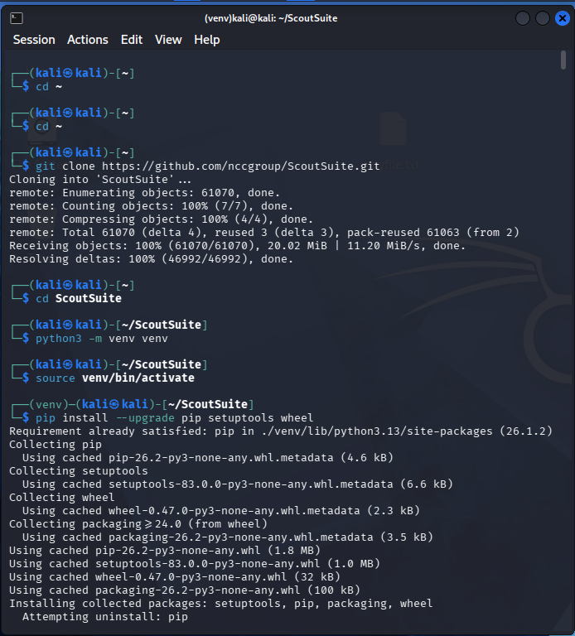

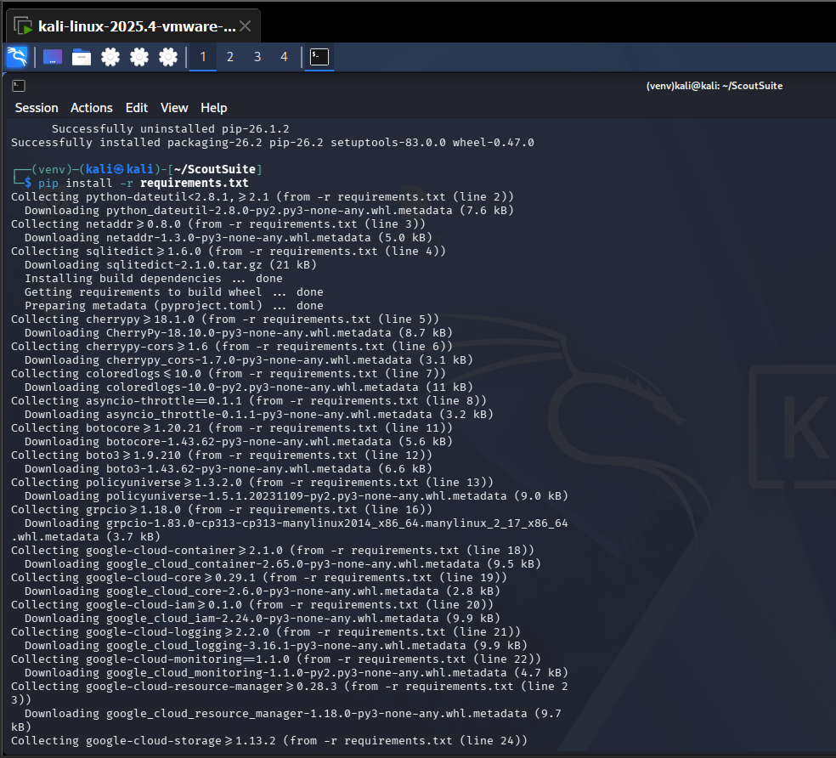

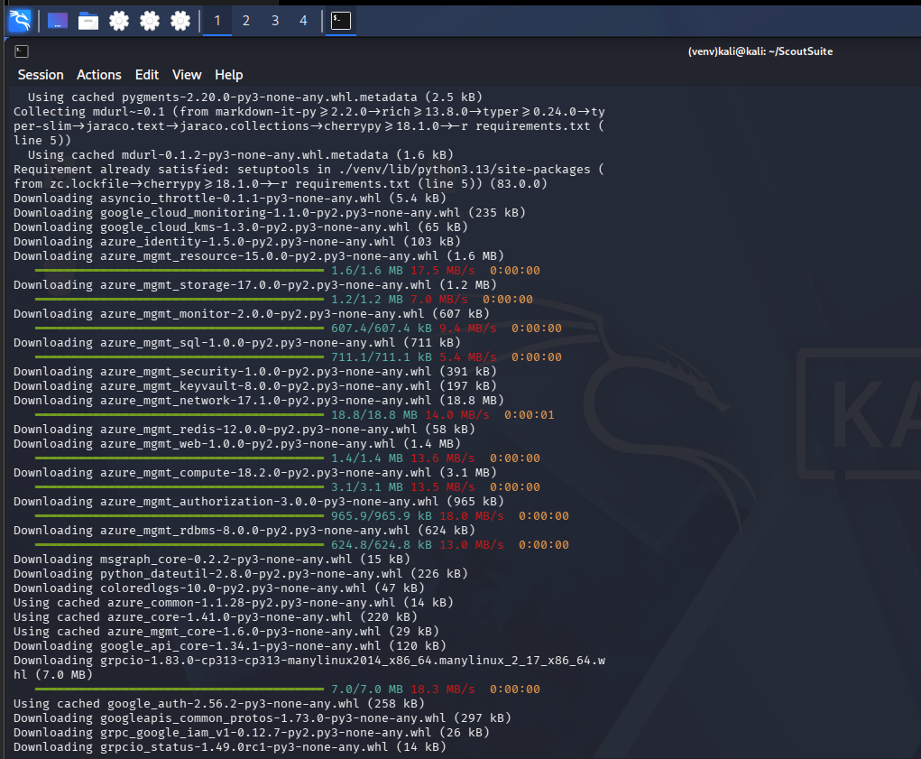

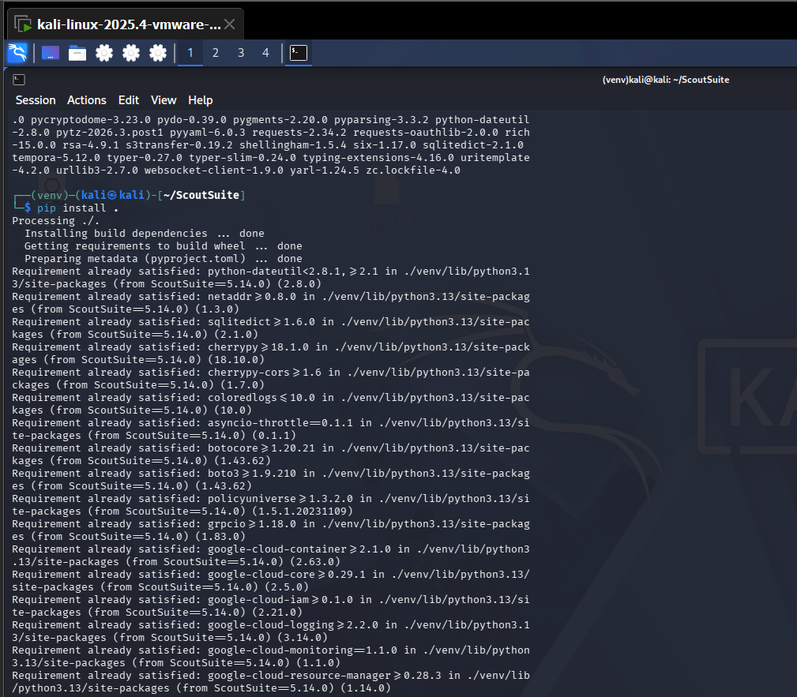

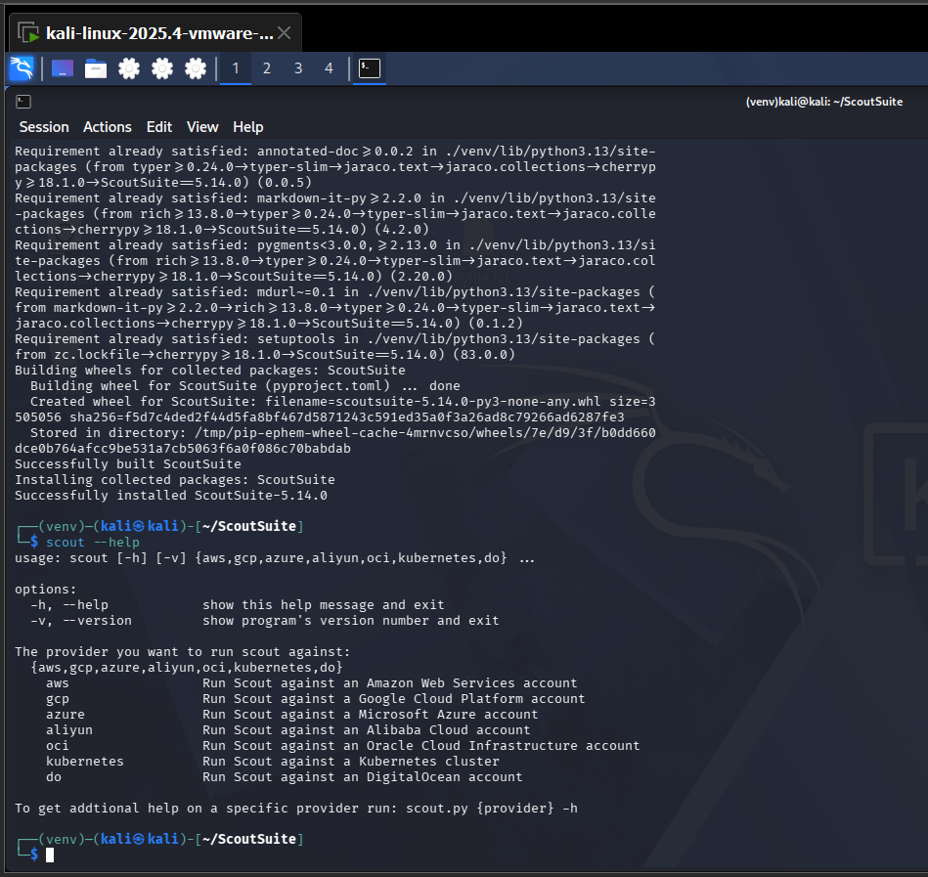

Scoutsuit scan running
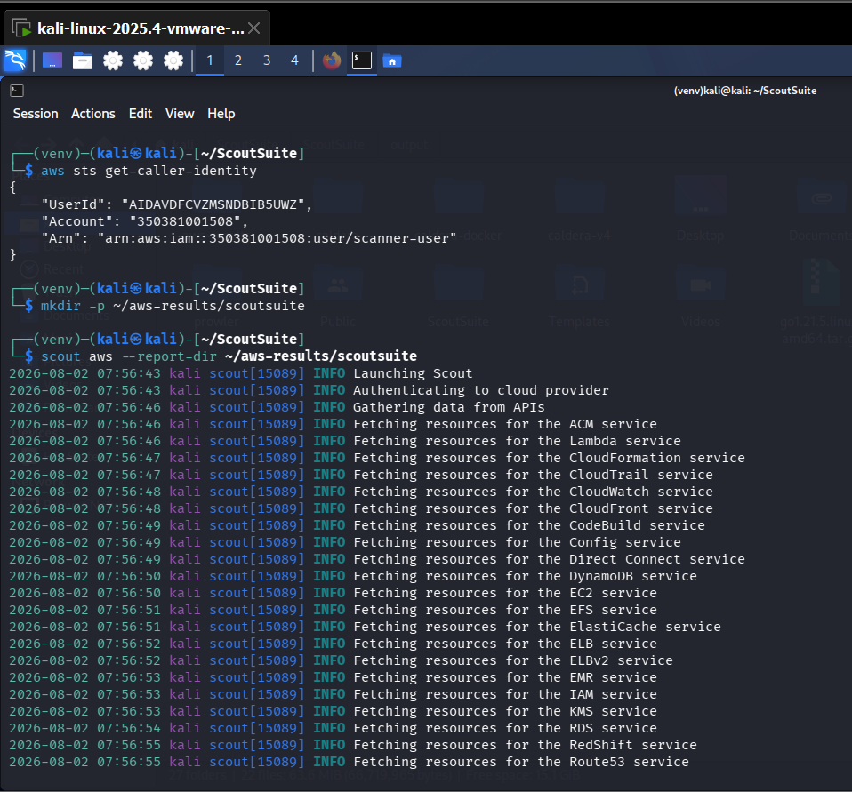

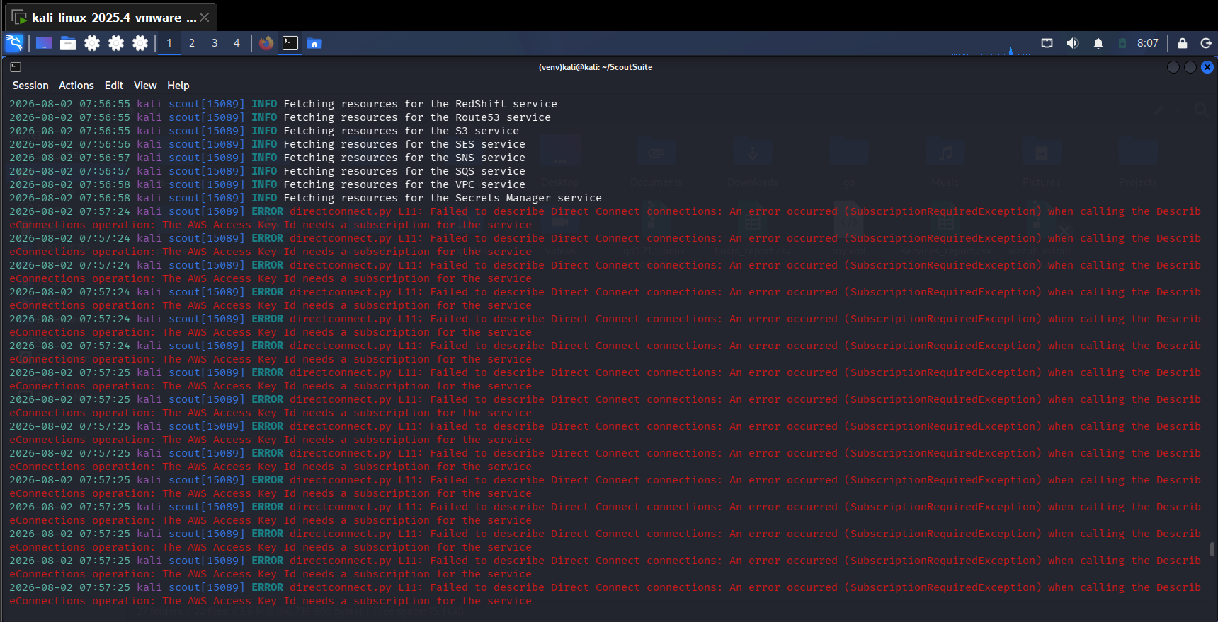

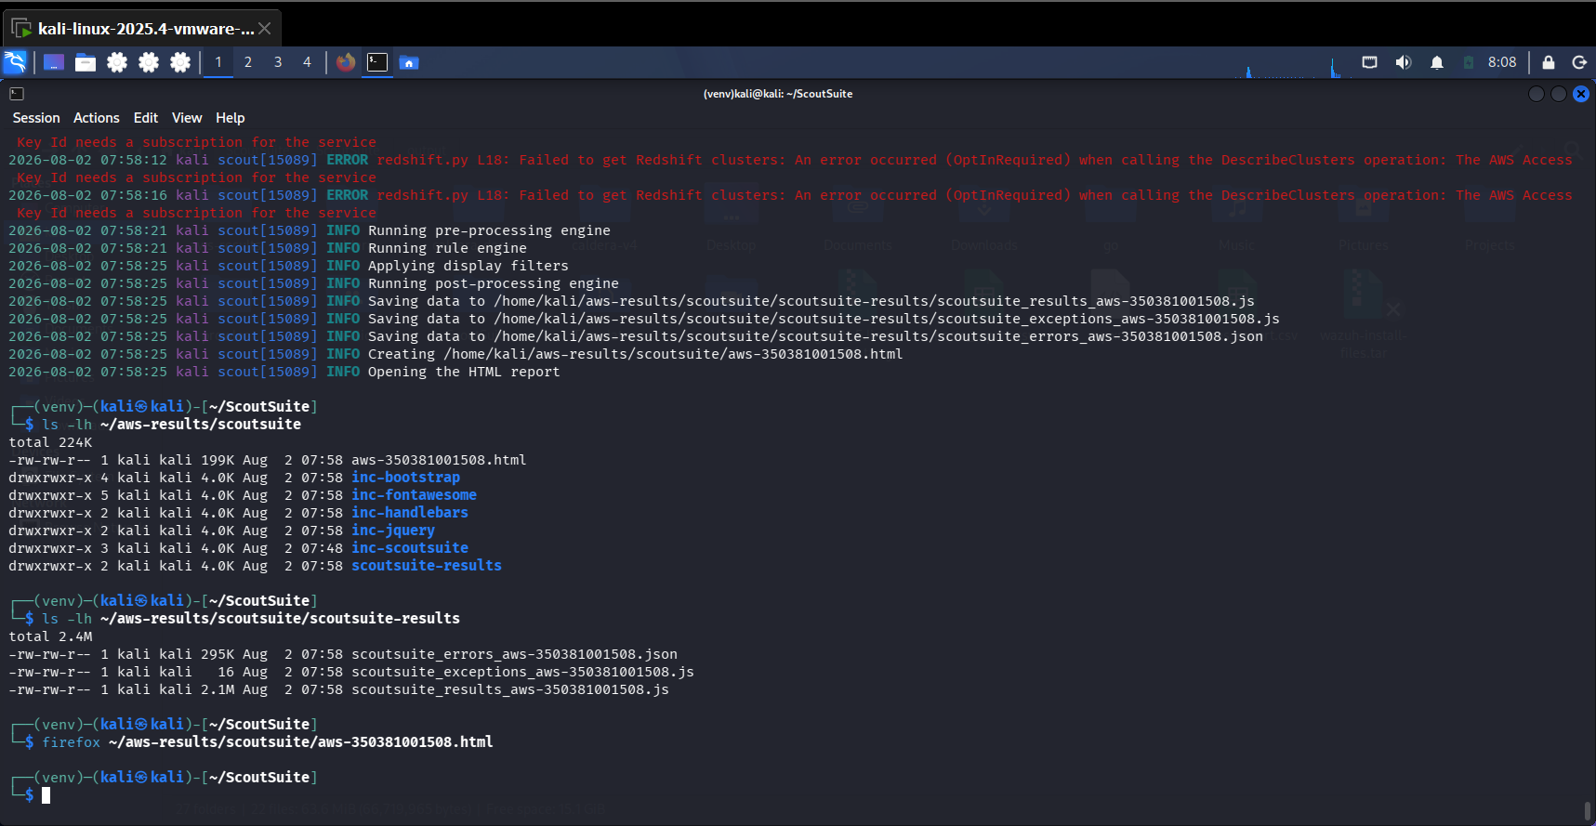

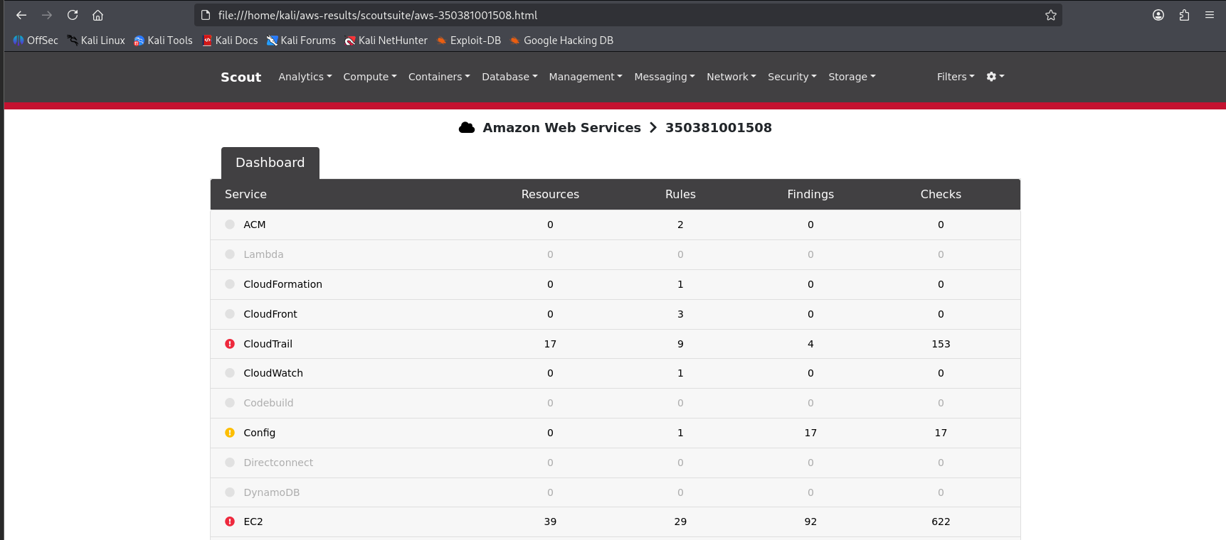

Cloudsploit installation
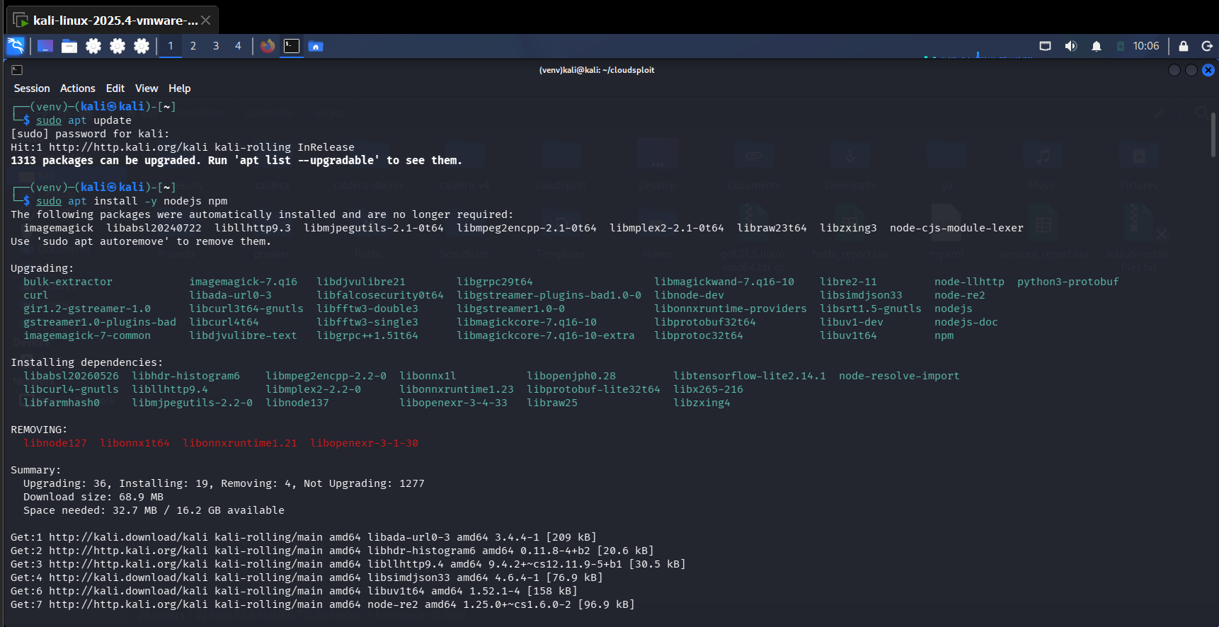

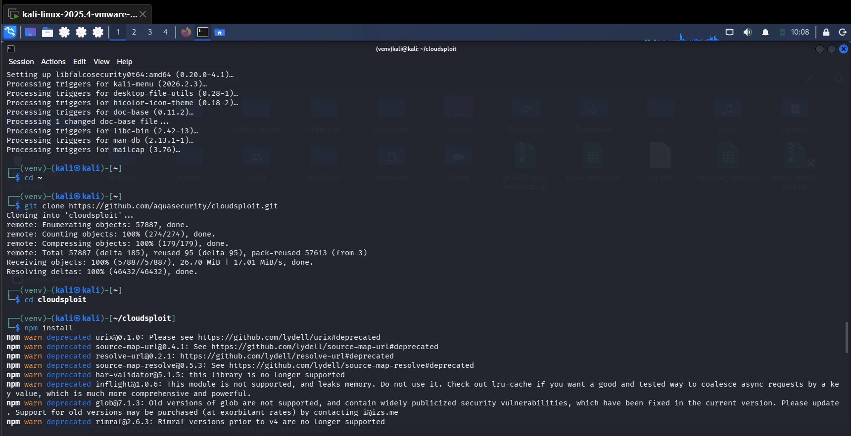

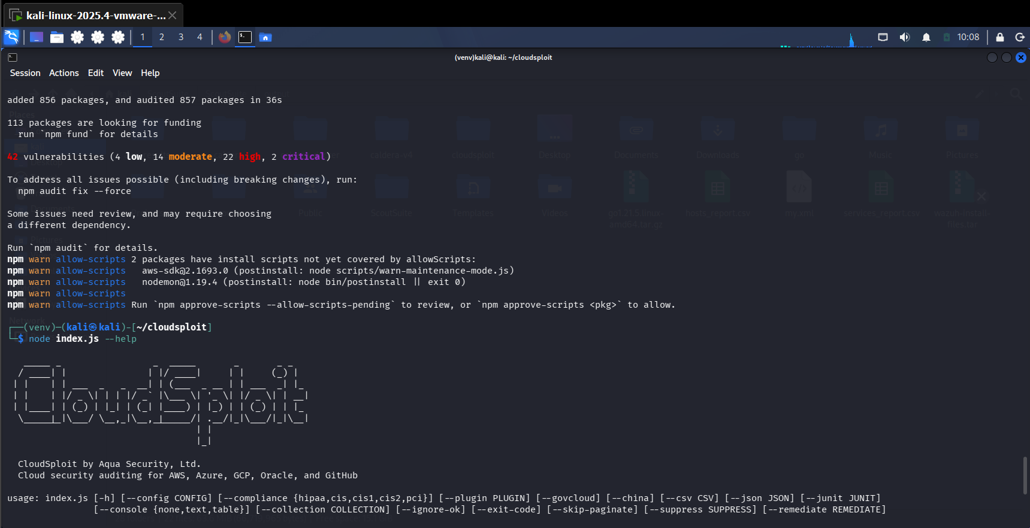

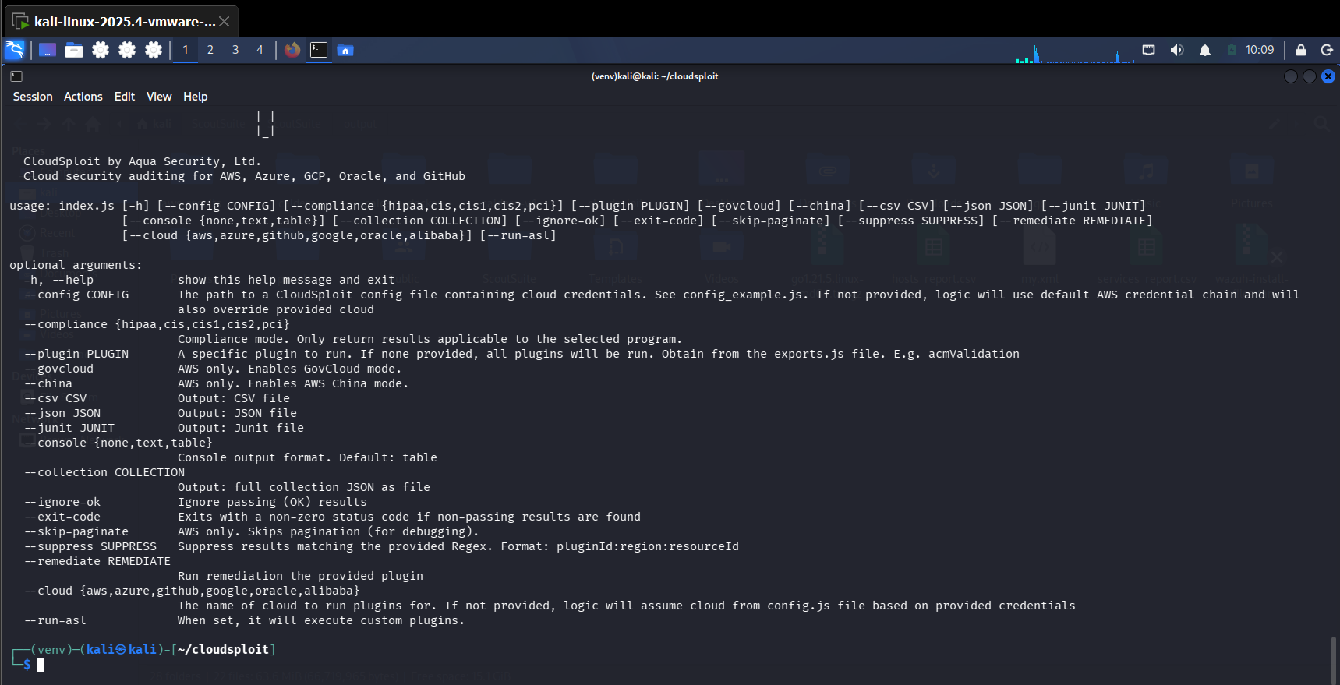

Run CloudSploit
